Contents

Creating an App from a Spreadsheet 2

**Introduction** 2

**Task 2: Creating an application** 4

**Task 3: Running and exploring the new app** 8

**Summary** 11

Improving the Faceted Search 12

**Introduction** 12

**Task 1: Enhancing the Safe Facet** 12

**Task 2: Collapsing Facets** 17

**Task 3: Filtering Facets** 18

**Summary** 19

Improving the Report and Form 20

**Introduction** 20

**Task 1: Enhancing the Interactive Report** 20

**Task 2: Enhancing the Form** 33

**Task 3: (OPTIONAL) Enhancing the UX of the Form** 39

**Summary** 45

Using Maps and Progressive Web App 47

**Introduction** 47

**Task 1: Creating a Copy of an Existing Page** 47

**Task 2: Adding a Map Region** 51

**Task 3: Enhancing the Map Region** 57

**Task 4: Installing a Progressive Web App (PWA)** 68

**Summary** 70

# Creating an App from a Spreadsheet

In this lab, you learn to create an APEX application using the data imported from a spreadsheet. You will learn to import a spreadsheet which consists of a list of High Schools in New York City. [Click here](https://oracle-livelabs.github.io/apex/spreadsheet/2-creating-an-app-from-a-spreadsheet/files/nyc_high_schools.csv) to download the spreadsheet for this lab.

**Introduction**

Now that you are logged into your workspace, you can start creating APEX applications. In this lab, you build a simple application based on a spreadsheet. Keep in mind that APEX is great for a variety of apps, from simple ones like this to large, sophisticated apps based on local database objects, REST enabled SQL objects, and even REST APIs.

While APEX developers spend the majority of their time in the **App Builder**, you should also investigate the following:

* **SQL Workshop**: where you can create and maintain database objects.
* **Team Development**: where you can track large APEX development projects.
* **Gallery**: which contains numerous productivity and sample apps that can be installed within minutes.

**Note:** The screenshots in this workshop are taken using Dark Mode in APEX 22.1.

Estimated Time: 5 minutes

Collapse All Tasks

**Task 1: Loading the Highschool data**

1. From your APEX workspace home page, click **App Builder**.
2. Click **Create a New App**.
3. Click **From a File**.

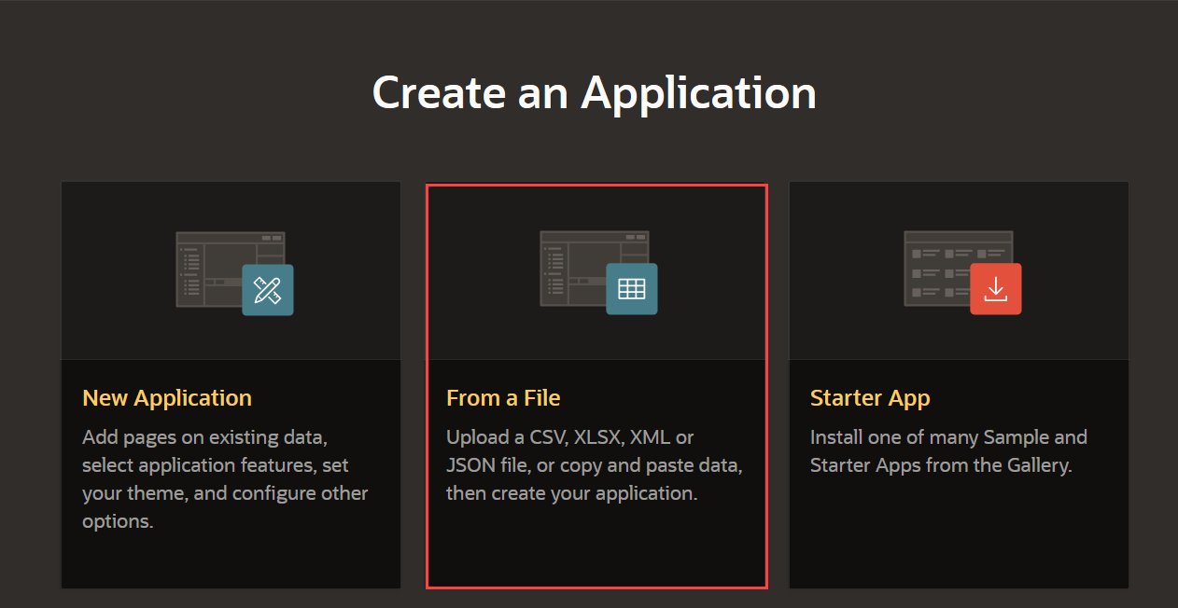

When creating an application from a file, APEX allows you to upload CSV, XLSX, XML, or JSON files and then build apps based on their data. Alternatively, you can also copy and paste CSV data or load sample data.

1. Within the Load Data wizard, click the **Choose File** option or drag and drop the [nyc_high_schools.csv](https://oracle-livelabs.github.io/apex/spreadsheet/2-creating-an-app-from-a-spreadsheet/files/nyc_high_schools.csv) file on to the dialog window.

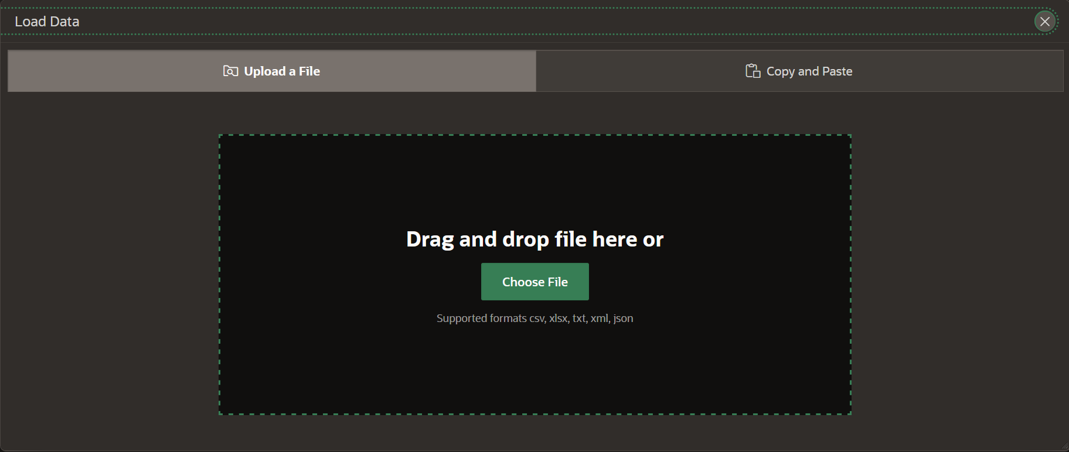

1. Review the parsed data. Set Table Name to **NYC_HIGHSCHOOLS** and click **Load Data**. Note: You can configure what columns to load from the spreadsheet by clicking the **Configure** button.

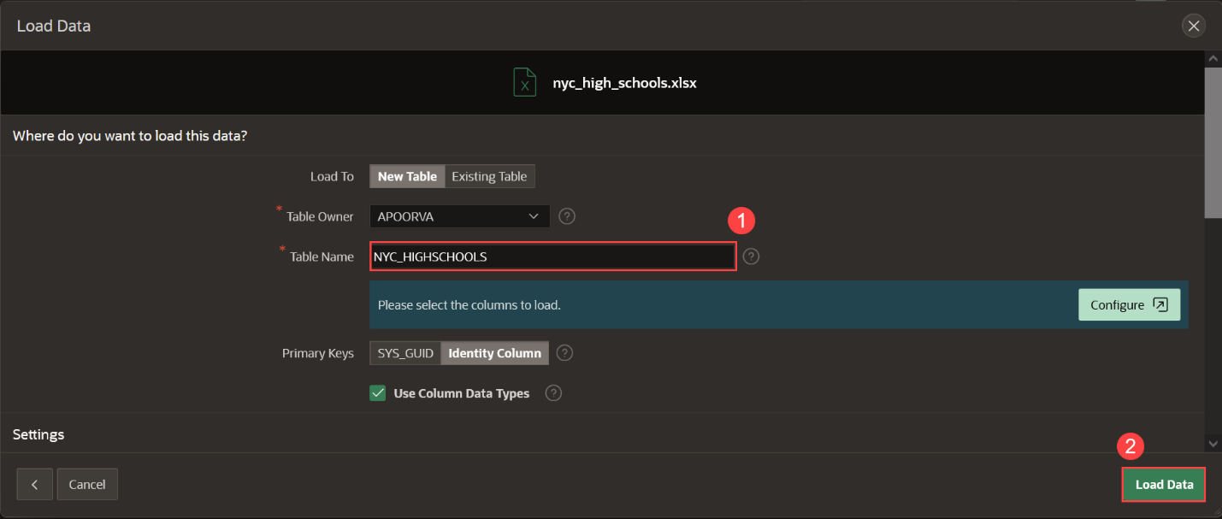

After clicking **Load Data**, you will see a spinner until the wizard finishes loading the data. Continue to Task 2 at that point.

**Task 2: Creating an application**

The Data Load wizard has created a new table and populated that table with the records from the sample data. Now you can create an app based on this new table.

1. In the Load Data dialog, verify that 427 rows have been loaded into the **NYC_HIGHSCHOOLS** table, then click **View Table**.

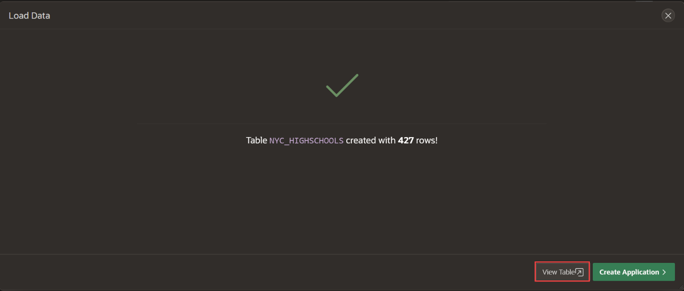

1. In the Object Browser, review the table structure.  
   In the Table toolbar, click **Create App**.

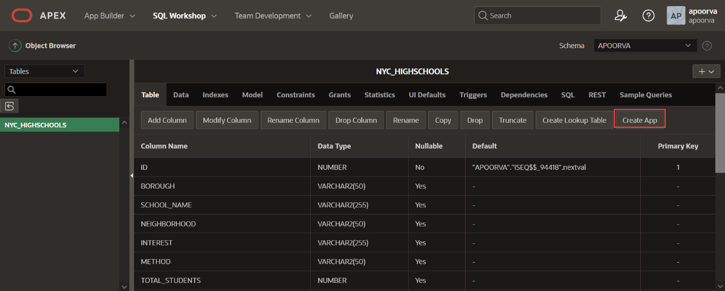

1. On the Create Application page, click **Create App**.
2. On the Create Application page, enter the Name as **NYC Highschools** and click the application icon.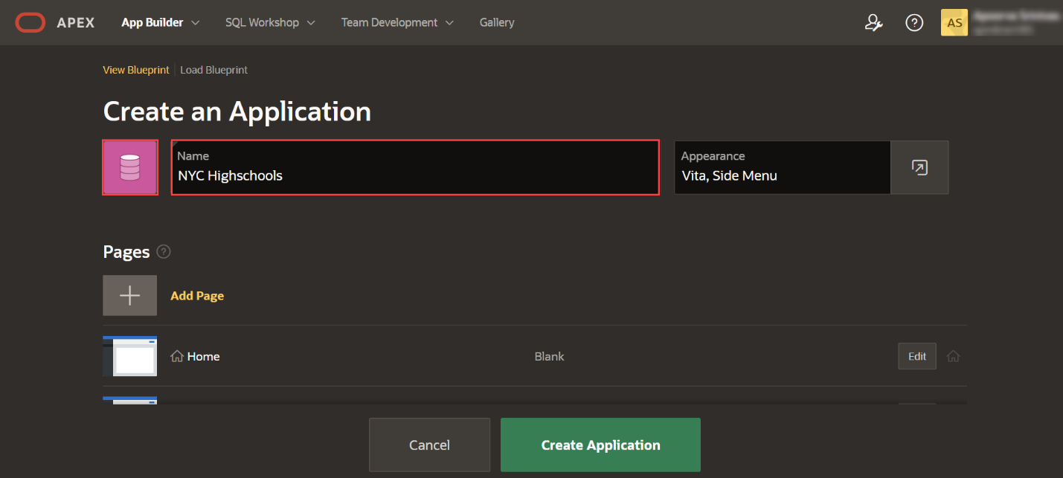
3. In the Choose Application Icon wizard, upload your own icon by selecting or dragging and dropping an image. Download a sample icon from [here](https://oracle-livelabs.github.io/apex/spreadsheet/2-creating-an-app-from-a-spreadsheet/files/nyc-highschools.png).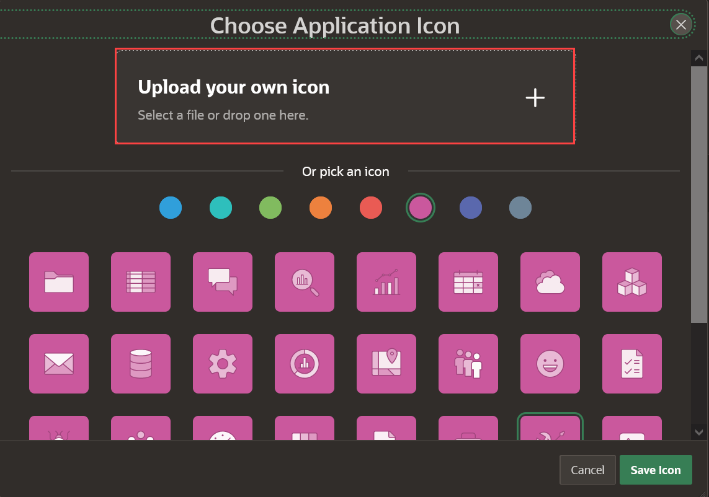
4. Once you select an image, the wizard allows you to crop or resize the image. Click **Save Icon**.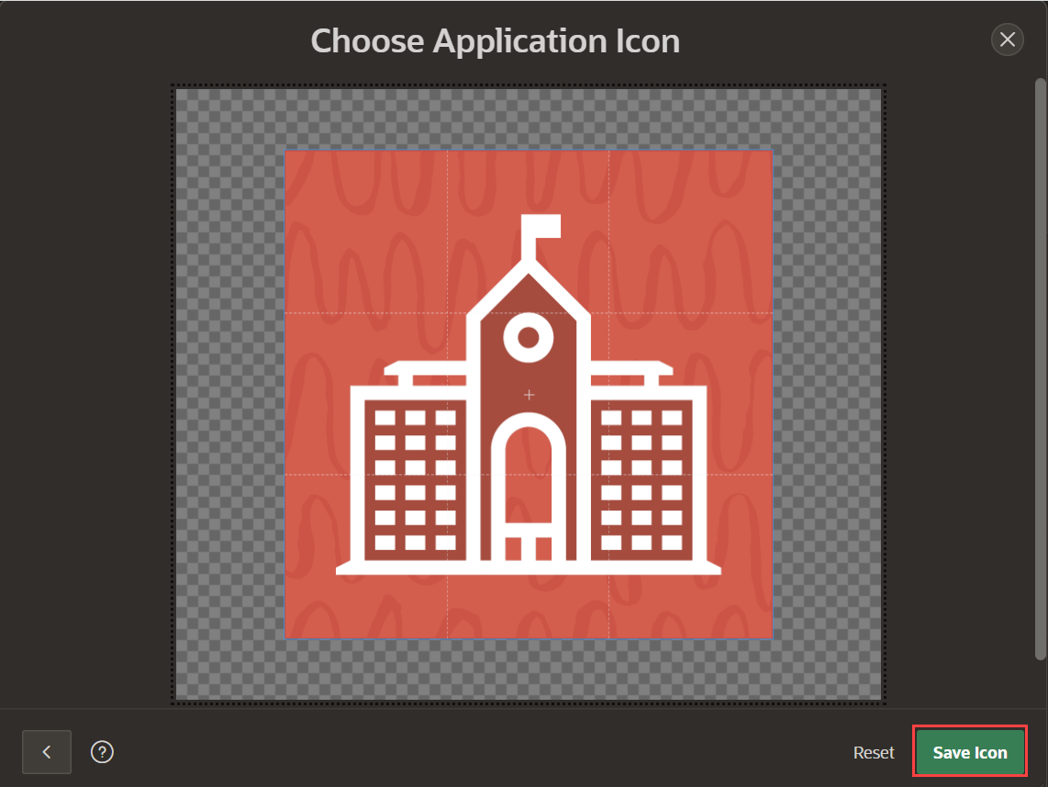
5. In the Create Application page, review the pages listed. Click the **Edit** button for **Nyc Highschools Search** and **Nyc Highschools Report** pages to review more details and update the names to the following:

* NYC Highschools Search
* NYC Highschools Report

Click the checkbox for **Install Progressive Web App** for Features, and then click **Create Application**. You will learn about Progressive Web App in *Lab 4* of this workshop.

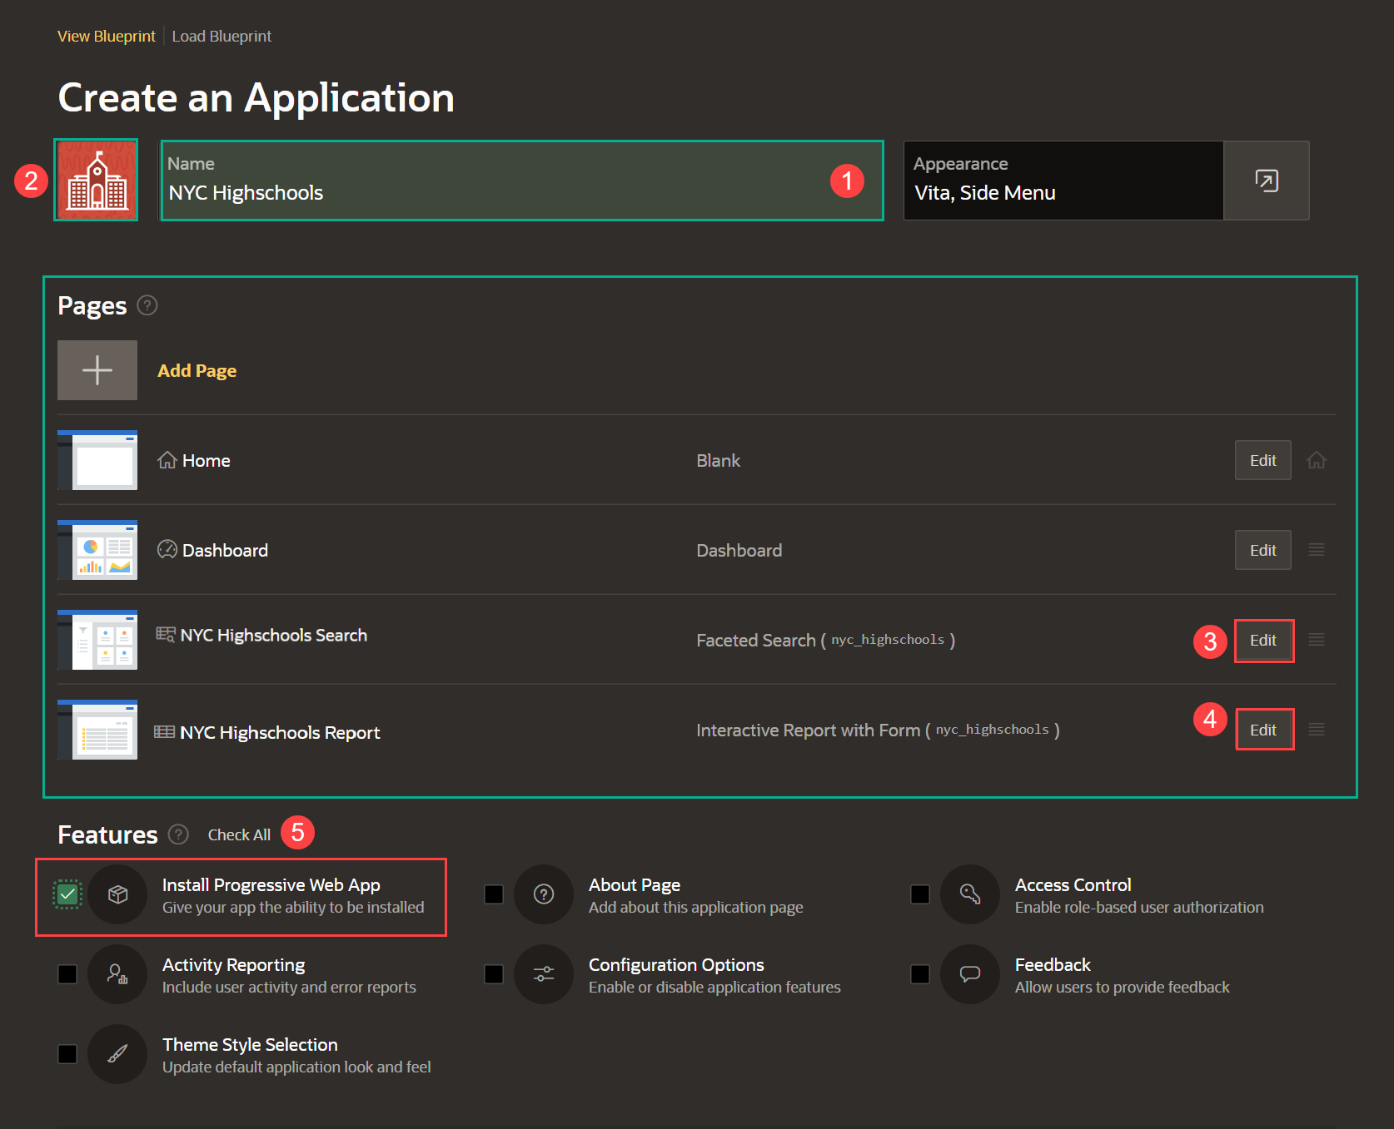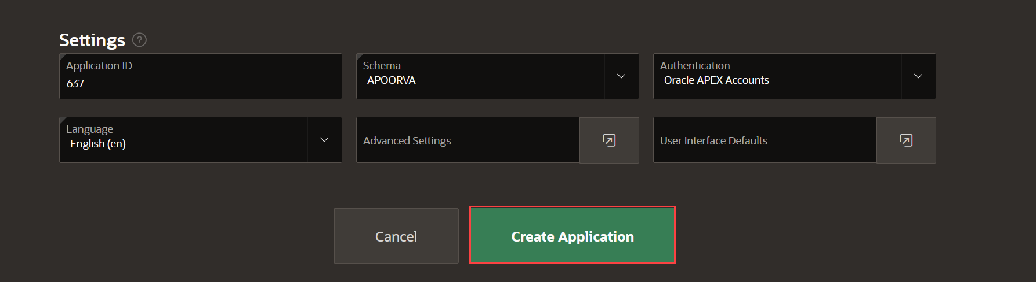

When the wizard finishes creating the application, you will be redirected to the application's home page in the App Builder.

**Task 3: Running and exploring the new app**

1. Click **Run Application**. This will open the runtime application in a new browser tab, allowing you to see how end users will view the app.

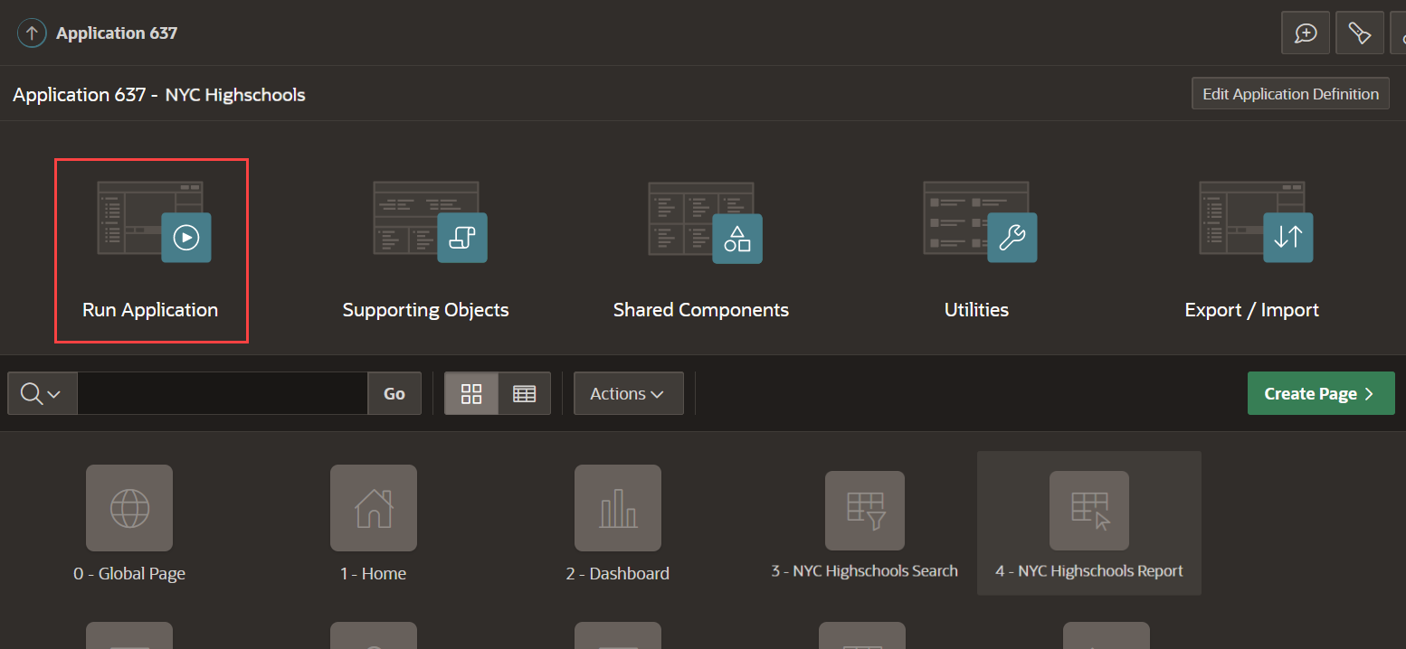

1. Enter your user credentials and click **Sign In**. Notice the custom application icon displayed at the top.

*Note: Use the same Username and Password you used to sign into the APEX Workspace.*

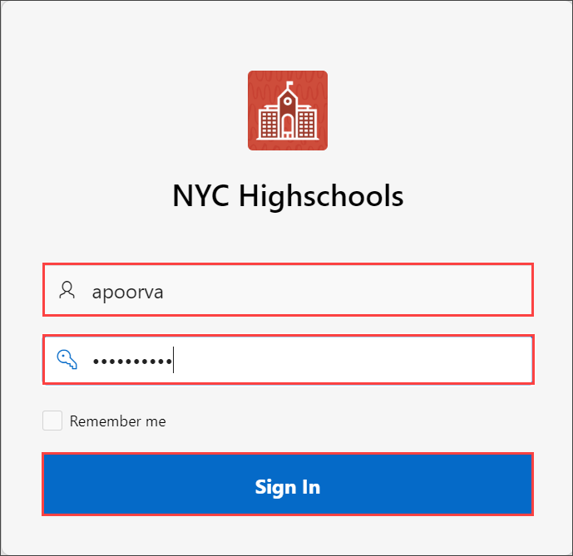

1. Explore the application a little.

* Click **Dashboard** (in the home menu or the navigation menu) to view the charts created.
* Click **NYC Highschools Search**, in the navigation menu, to play with the faceted search.
* Click **NYC Highschools Report** to view an interactive report, then click the edit icon for a record to display the details in an editable "form" page. Finally, review the options available under **Administration**.

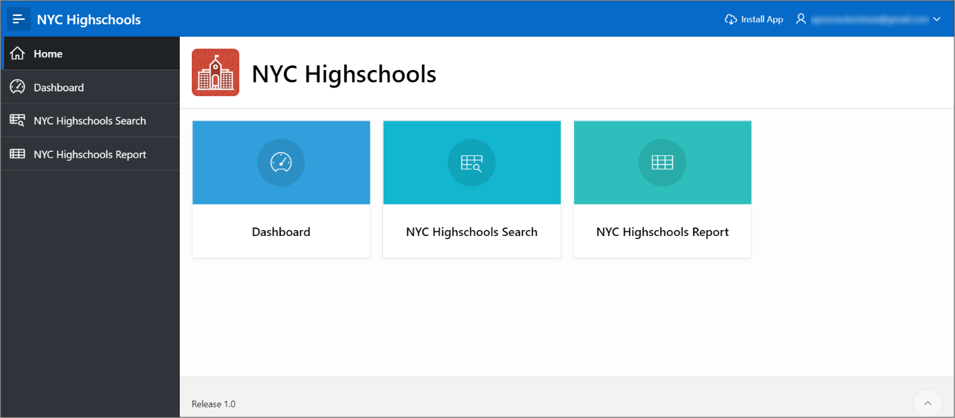

**Summary**

You now know how to create an application from a spreadsheet by dragging and dropping a file.

# Improving the Faceted Search

**Introduction**

In this lab, you will get a first-hand experience with enhancing the application by improving the faceted search page for better clarity and improved usability. The search page includes facets on the left which can readily be used to limit the data shown in the report on the right.

If you review the **NYC Highschools Search** page, you can check and uncheck various facets. When you check a facet, the counts on all of the remaining facets will be updated to show the number of records that meet the new criteria.

Estimated Time: 10 minutes

Collapse All Tasks

**Task 1: Enhancing the Safe Facet**

Reviewing the facets, you will notice that **Safe** is down the page and you can choose multiple range values from a checkbox group.

1. From the runtime application, go to the search page by clicking **NYC Highschools Search**. Assuming that you ran this app from the APEX App Builder, a Developer Toolbar is displayed at the bottom of the screen. *Note - End users who log directly into the app will not see this toolbar.*

In the Developer Toolbar click **Page 3**.

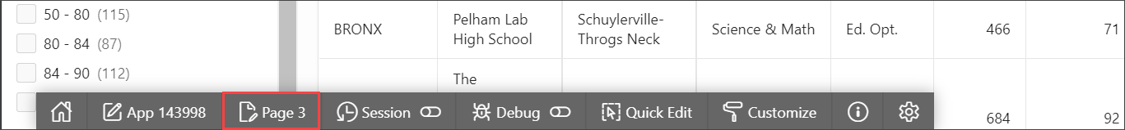

Alternatively, you can also navigate back to the APEX App Builder tab in your browser manually by selecting the appropriate browser tab or window. Once in the App Builder click **3 - NYC Highschools Search**.

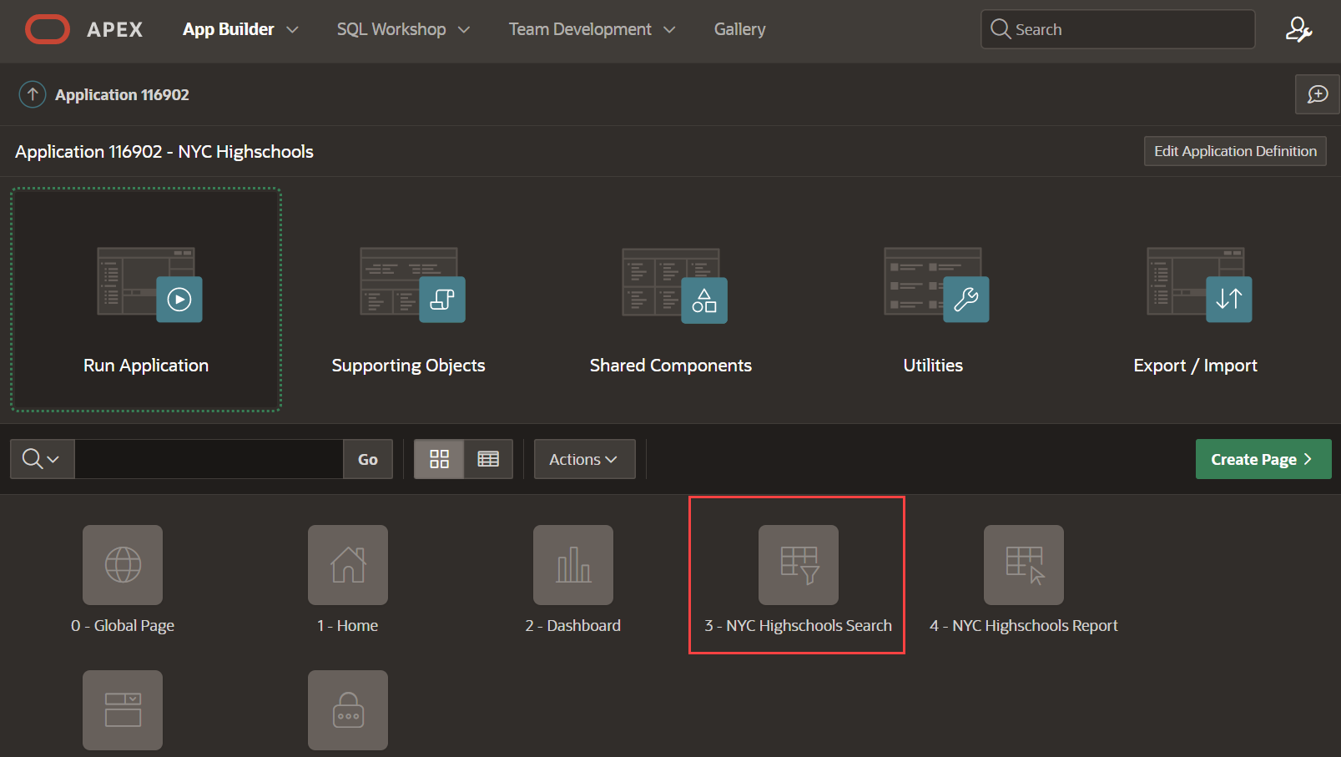

You should now be in the Page Designer. Page Designer is where you will spend the majority of your time improving your application. There are three panes within Page Designer.

* + The left pane initially displays the Rendering tree, with a list of page components.
  + The middle pane displays the Layout, a representation of the page, and Gallery, from which you can drag and drop new components into the Layout.
  + The right pane is the Property Editor, where you can change attributes for the selected component.

1. Safety of a Highschool is a very important search criteria while selecting a High School, so you want to reorder the facets such that **Safe** is between *Borough* and *Interest*.

In the Rendering tree (left pane), under **Search**, within **Facets**, click and hold **P3_SAFE** and drag it up until it is under **P3_BOROUGH** then release the mouse.

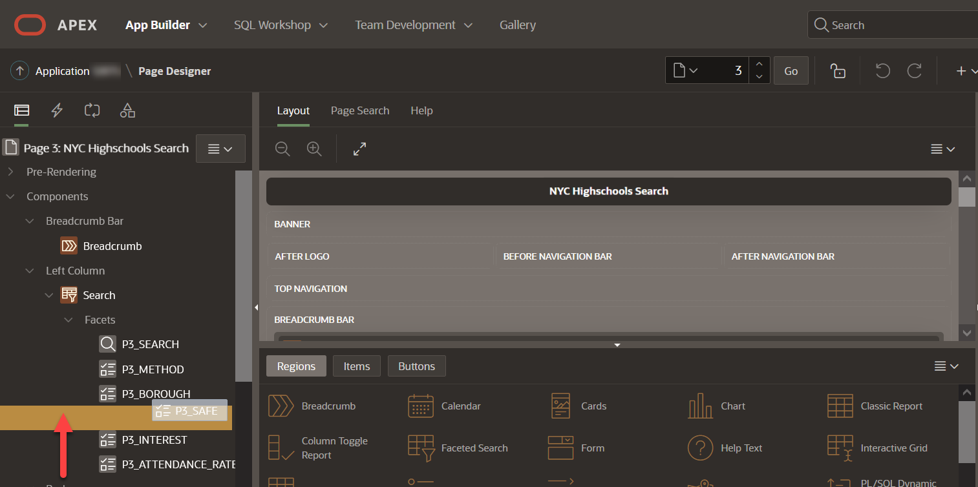

1. Currently the **Safe** facet is a checkbox group with range values. However, it is unlikely that users will want to select multiple safety percentage value, so you will convert it into a radio range group.

Continuing with **P3_SAFE** selected, within the Property Editor (right pane), under **Settings**, toggle the **Select Multiple** button such that multiple values cannot be selected.

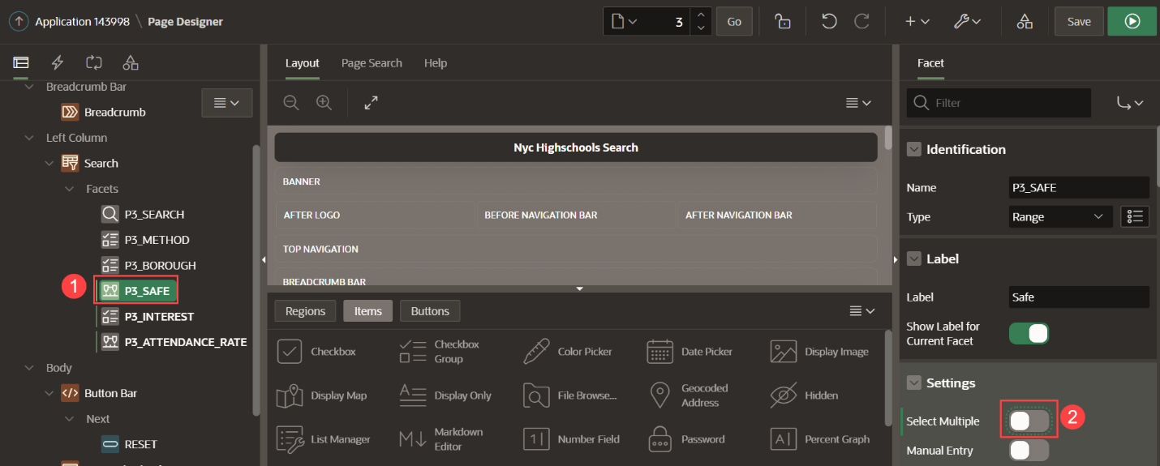

1. At the top right of the page click **Save and Run Page** to save the changes made to the facets and review the app.



1. In the runtime environment, click one of the **Safe** ranges. Review how the counts on the other facets are updated based on your selection. Also notice how you can still select one of the other **Safe** ranges or click **Clear**, within the **Safe** facet, to clear your selection and again show all the counts for all the safety ranges.

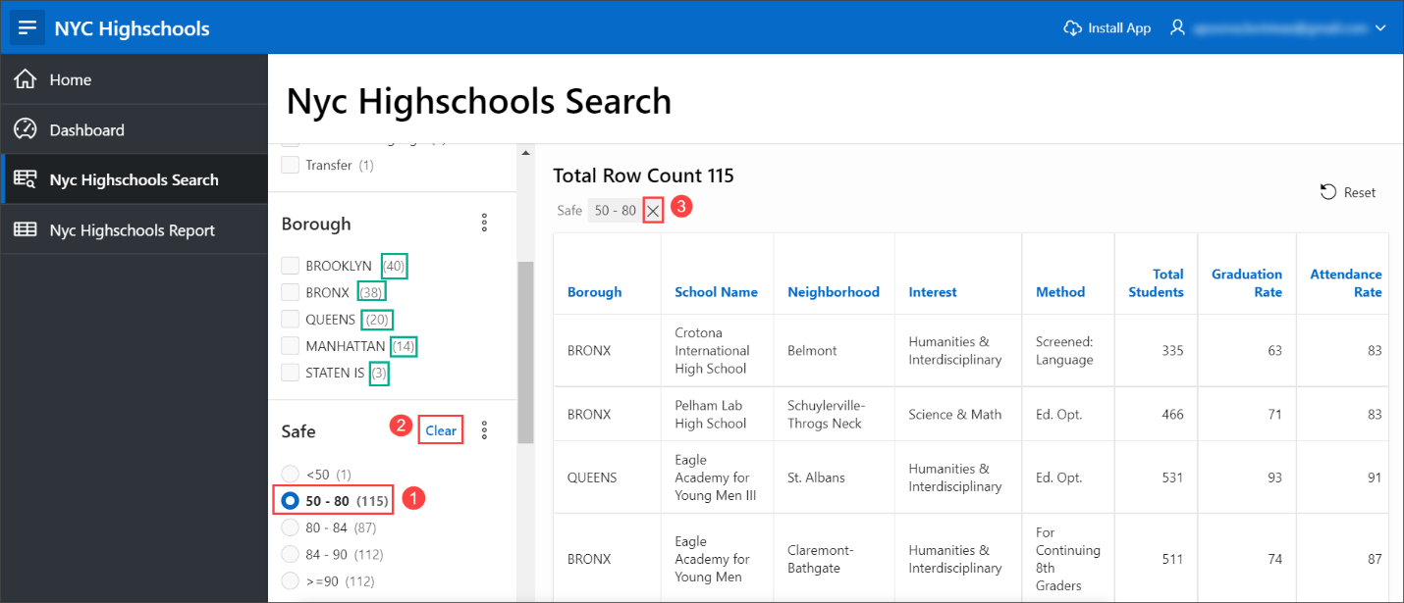

*Note*: As an optional step, you can follow the same steps in **STEP 1** to customize the **Attendance Rate** facet.

1. You can view each of the facets and their respective counts as a chart. To view the chart, click on the context menu next to the **Borough** facet and select **Show Chart**. A chart dialog window is displayed with the Borough names on the X-axis and the count on the Y-axis.

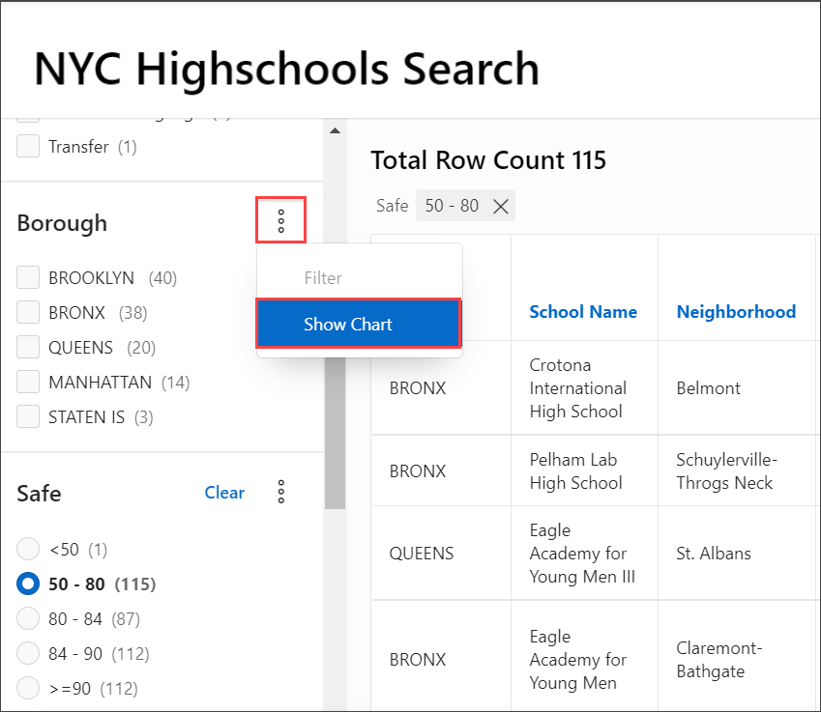

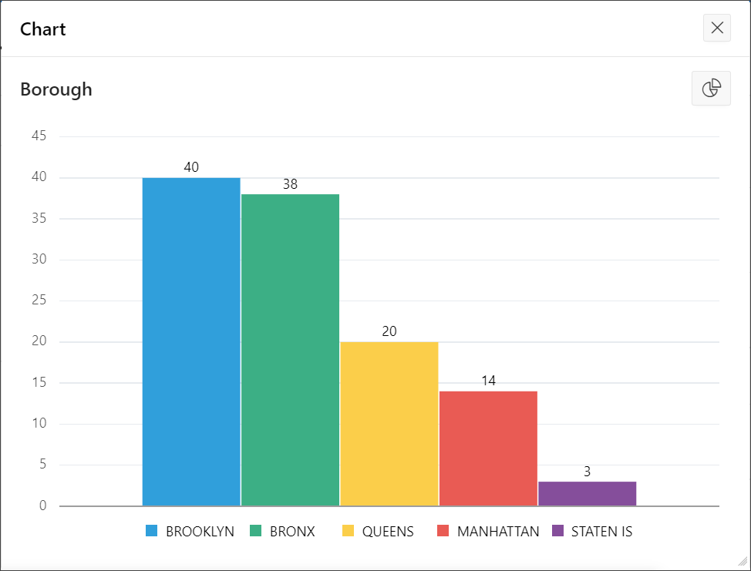

**Task 2: Collapsing Facets**

1. You may have noticed that the facets go off the bottom of the page. Therefore, it would be preferable to collapse the last three facets, making it easier to see all available facets.

Navigate back to the development environment (APEX App Builder) by using the edit link in the Developer toolbar, or manually navigating to the appropriate browser tab.

In the Rendering tree (left pane), under **Search**, within **Facets**, click **P3_SAFE**, hold down the *Shift* key and then click **P3_ATTENDANCE_RATE**, such that three facets are selected. In the Property Editor (right pane), within the filter at the top, enter **collap**, so that Collapsible is displayed under Advanced. When you toggle the switch for **Collapsible**, **Initially Collapsible** property appears. For Advanced > Initially Collapsed, change the switch to selected.

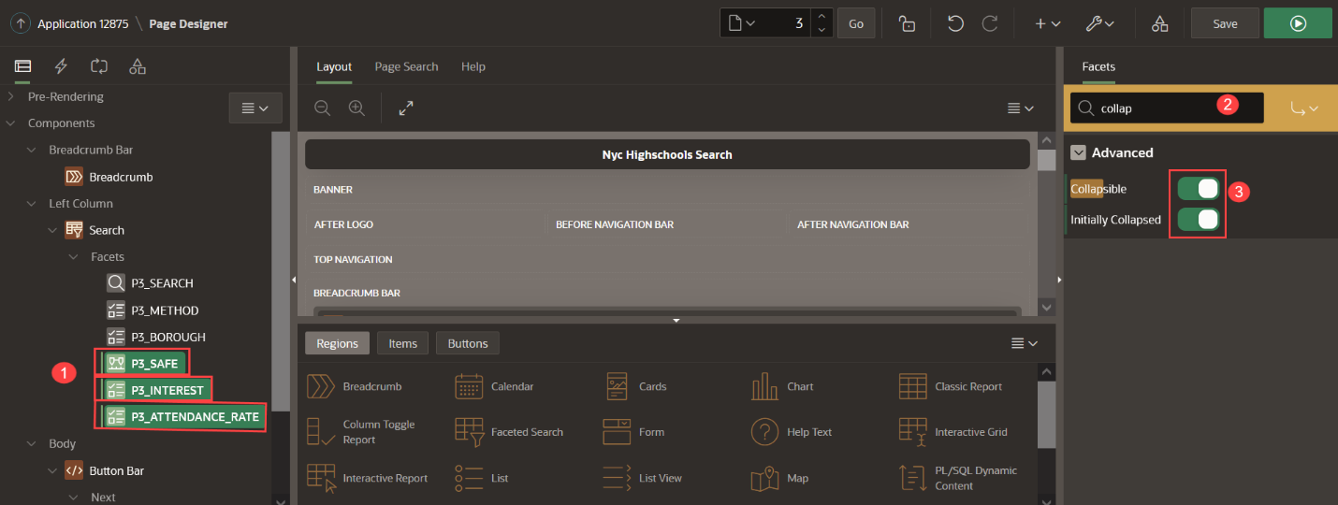

*Note - Rather than entering a filter you can also scroll down the properties until you find the correct attribute to update.*

1. Click **Save and Run Page** to see the improved search page.

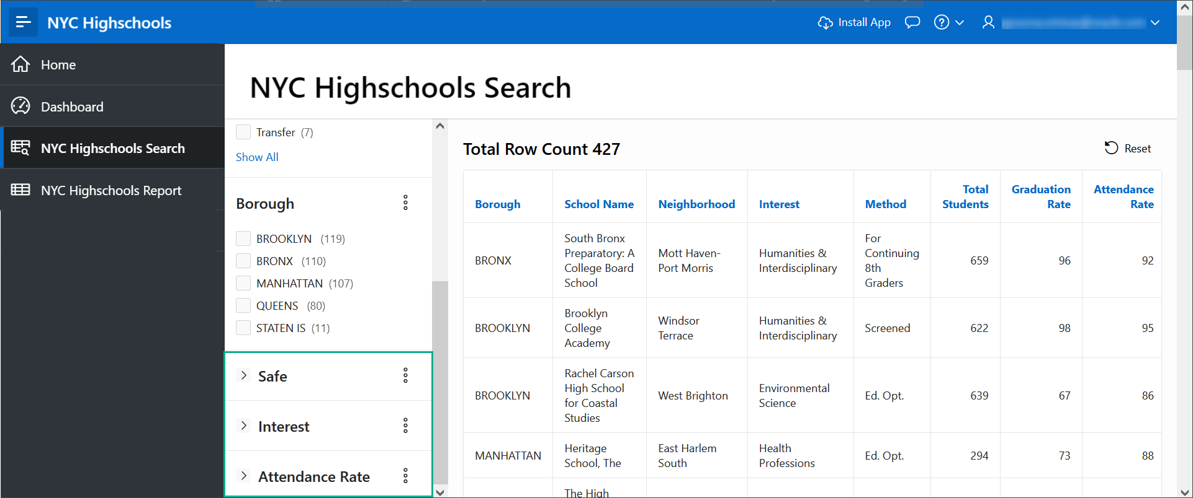

**Task 3: Filtering Facets**

1. Some facets may have multiple values to choose from and becomes difficult for the end user to scroll and select the values. APEX 22.1 introduces a new filter feature for facets which provides a search bar to search and filter facet values.

Click the context menu (three dots) next to the facet name **Method**. Select **Filter**.

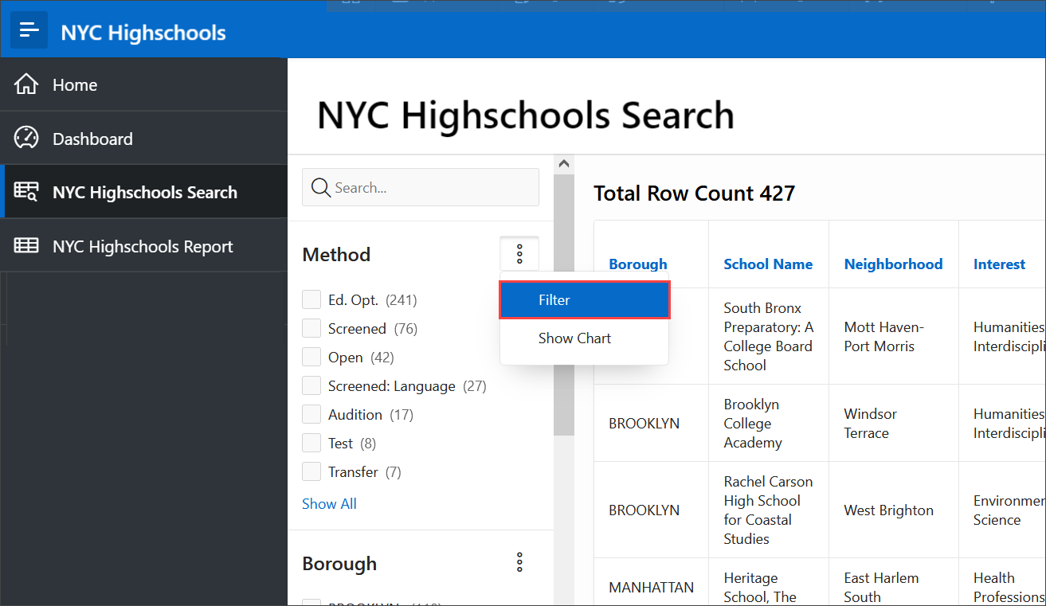

1. A search filter is displayed below the facet name. Type **Transf** in the text box and all the facet values that contain the substring will be displayed. You can then select the checkbox for **Transfer** to be filtered in the report.

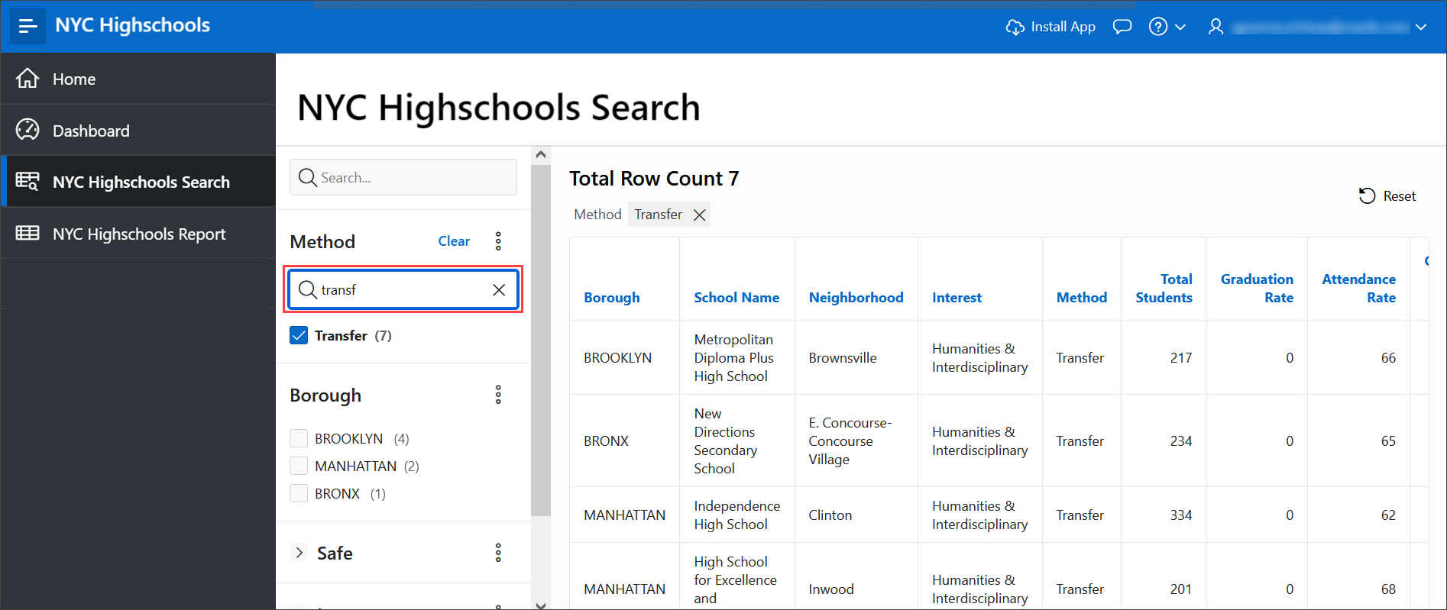

**Summary**

You now know how to enhance a faceted search page and modify the properties on a page using the Page Designer.

# Improving the Report and Form

**Introduction**

In this lab, you will gain an insight into the abilities of Interactive Reports, and learn how to enhance a form page.

Estimated Time: 20 minutes

Collapse All Tasks

**Task 1: Enhancing the Interactive Report**

The **NYC Highschools Report** page utilizes an Interactive Report to display the records. Interactive Reports are exceedingly powerful, as they allow *end users* to modify what data is displayed, and various display characteristics. For this report, you will add a column break, a computational column, an aggregate, a chart, then order the data and save the report for everyone to see.

*Note - All of the steps below, except for saving Alternative Reports, can be performed by end users. There are many additional capabilities available to end users which are not covered below.*

1. In the runtime environment, click **NYC Highschools Report**.
2. The report displays all the columns in the table. Customize the report by choosing only selected columns in a report. Click **Actions** and select **Columns**.

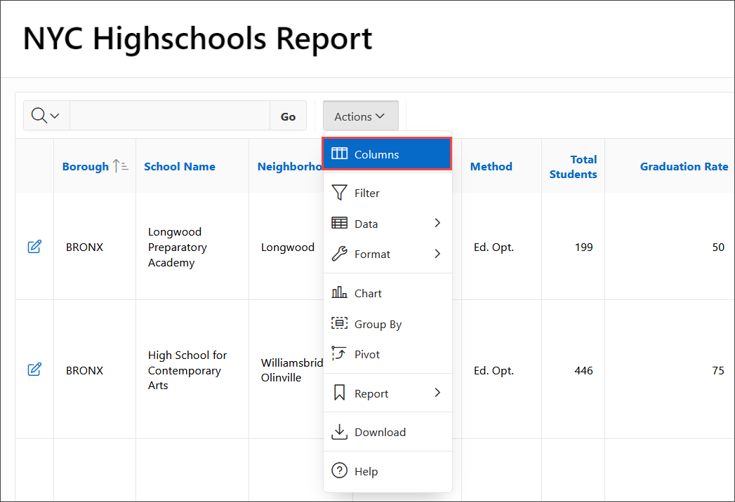

1. In the Select Columns dialog, select the columns that you want to hide from the report by selecting a column and clicking on the left-chevron (<) in order to move it to the **Do Not Display** section. Or, double-click on a column in order to move it to the **Do Not Display** section. Hide the following columns:
   * Dbn
   * Latitude
   * Longitude
   * Language Classes
   * Advanced Placement Courses
   * School Sports

Click **Apply**.

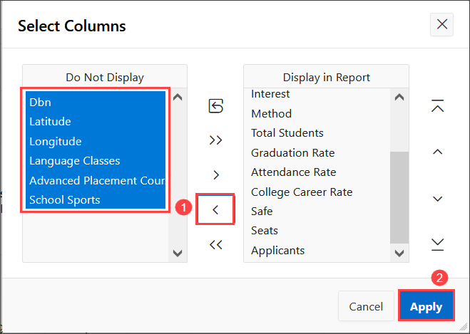

1. The interactive report is displayed by hiding the selected columns from the previous step. Click the **Neighborhood** column heading, and then select **Control Break**.

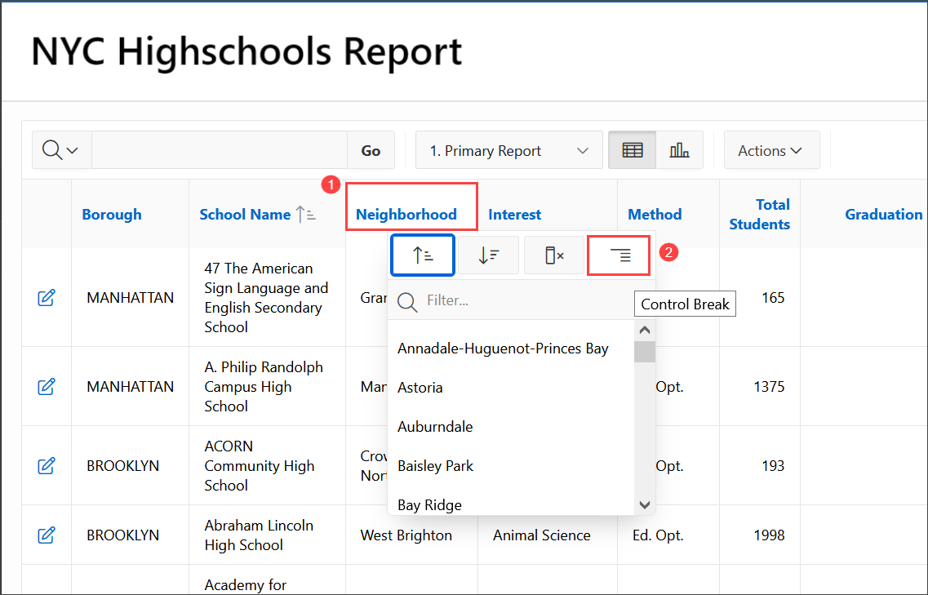

1. You can add a computational column, where a new column is defined based on a computation against one more existing columns in the report. Columns are selected within the computation using a letter associated with each column.

At the top of the report, click **Actions**, select **Data**, and then select **Compute**.

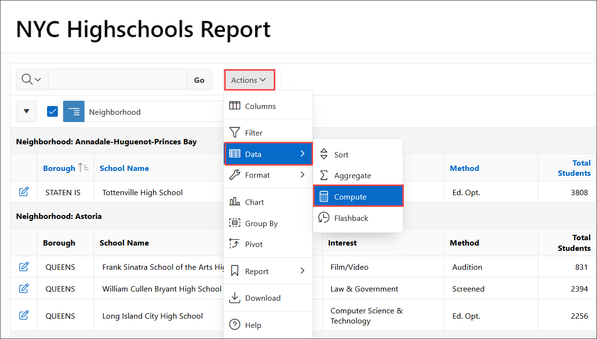

1. On Compute, enter the following and click **Apply**.

| Table 1: Building an App from a Spreadsheet using Oracle APEX | Lab 3: Improve the Report and Form | |
| --- | --- |
| **Property** | **Value** |
| Column Label | **Application to Seat Ratio** |
| Format Mask | **5,234.10** |
| Computation Expression | **M / L** |

1. 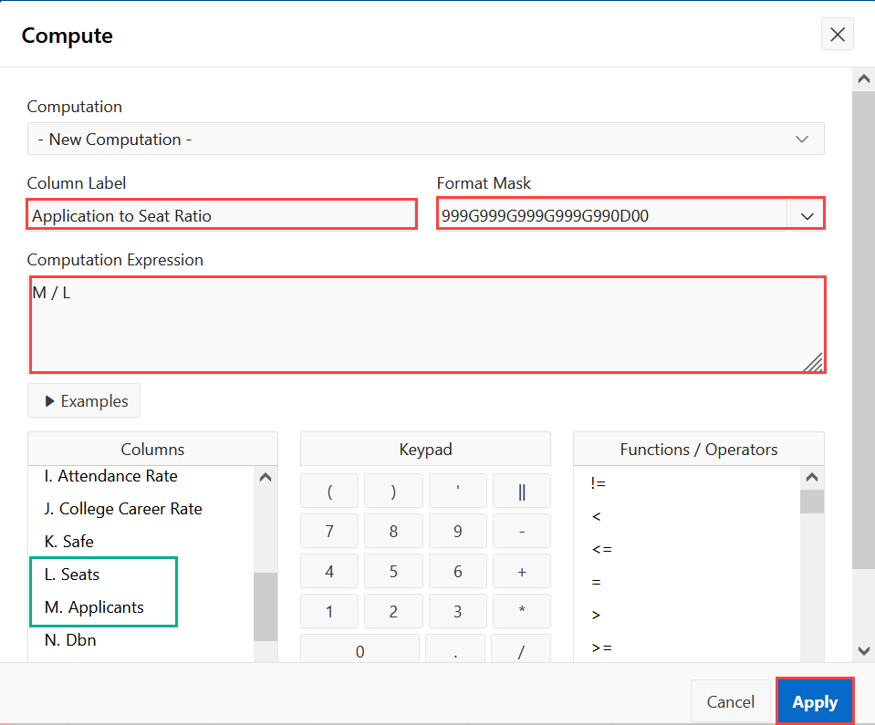
2. This adds a new column **Application to Seat Ratio** to your interactive report.
3. To calculate the average Application to Seat Ratio in each Neighborhood, click **Actions**, select **Data**, and then select **Aggregate**.

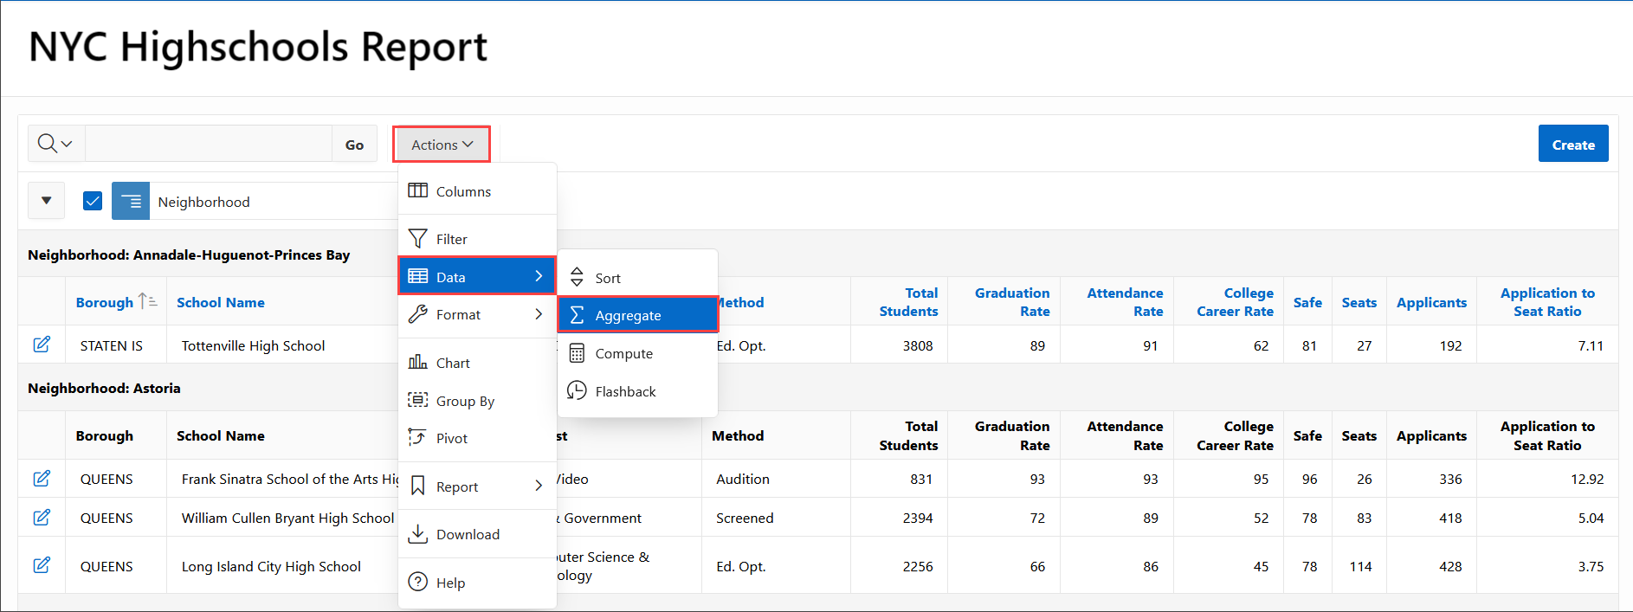

1. On Aggregate, for Column select **Application to Seat Ratio**, for Function select **Average**, then click **Apply**.

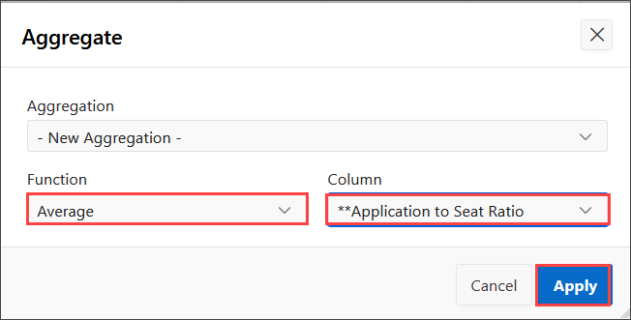

1. Even though you can see the average Application to Seat Ratio for each Neighborhood, it would be much easier to view the average on a chart to get an overall picture of the neighborhoods which have the best High Schools.

In the report click **Actions**, select **Chart**.

1. In the Chart dialog, select / enter the following and click **Apply**.

| Table 2: Building an App from a Spreadsheet using Oracle APEX | Lab 3: Improve the Report and Form | |
| --- | --- |
| **Property** | **Value** |
| Label | **Borough** |
| Value | **\*\*Application to Seat Ratio** |
| Function | **Average** |
| Orientation | **Horizontal** |

1. 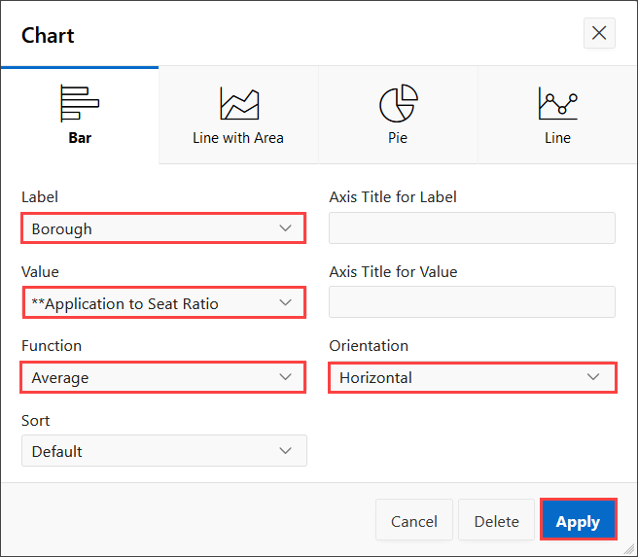
2. After you click **Apply**, the chart will be displayed. Hover over individual bars to view the neighborhood and the average. Toggle between the report view and chart view using the icons at the top of the report.
3. 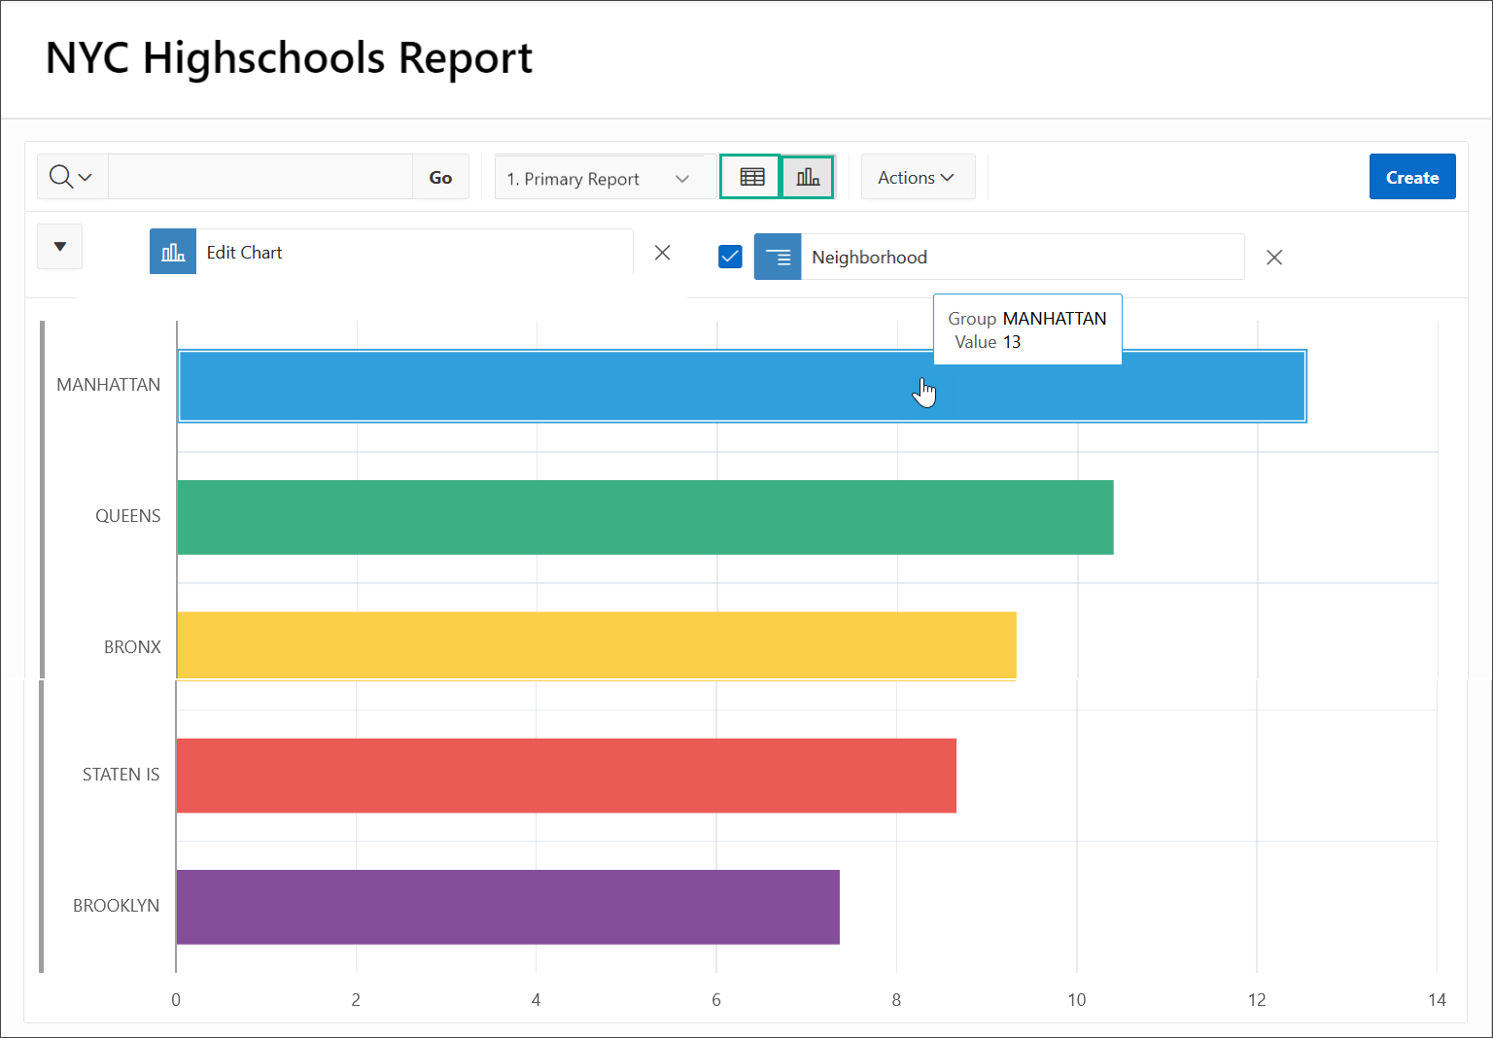
4. You want to ensure that all of the records are ordered in the ascending order of School Name and descending order of seats, within each neighborhood.

At the top of the report, click the **View Report** icon. Click **Actions**, select **Data**, and then select **Sort**.

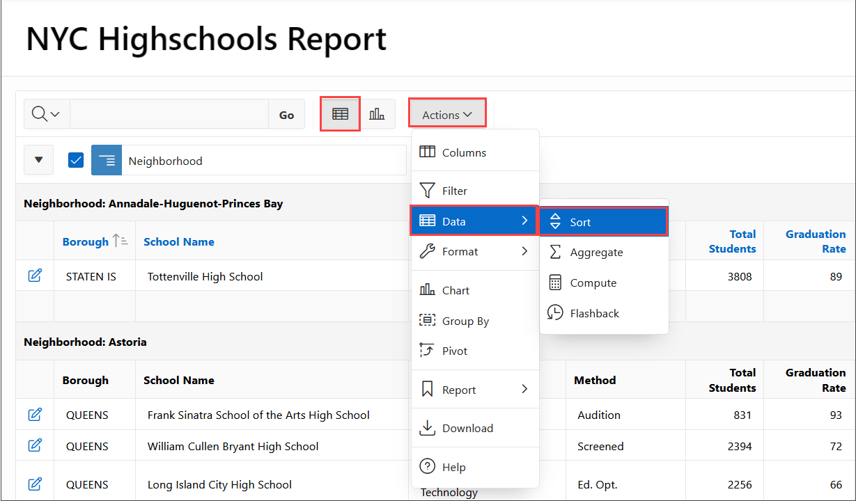

1. In the Sort dialog, select the following and click **Apply**.

| Table 3: Building an App from a Spreadsheet using Oracle APEX | Lab 3: Improve the Report and Form | | |
| --- | --- | --- |
| **Column** | **Direction** | **Null Sorting** |
| School Name | Ascending | Default |
| Seats | Descending | Nulls Always Last |
| Graduation Date | Descending | Default |

1. 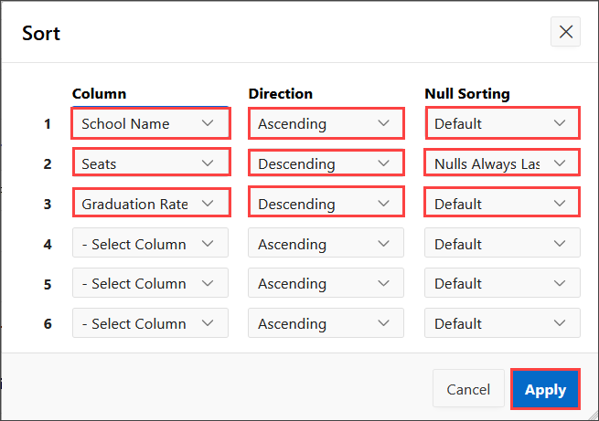
2. Now that you have made all of these modifications to the Interactive Report, it is important to save the report layout. End users have the ability to save either *Private Reports*, only they can view, or *Public Reports*, that other end users can also view. *{Note - As a developer you can remove the ability for end users to save Public Reports by going to the report attributes in Page Designer.}*

As a developer you also have the ability to save the report as the Primary (default) Report, or an Alternative Report. For this exercise you will save the report as a named Alternative Report.

In the report, click **Actions**, select **Report**, and then select **Save Report**.

1. In the Save Report dialog, for Save(Only displayed for developers) select **As Default Report Settings**.

*Note - End users can save Private and Public reports, however, only developers (who have run the app from the App Builder) can save the Primary and Alternative reports.*

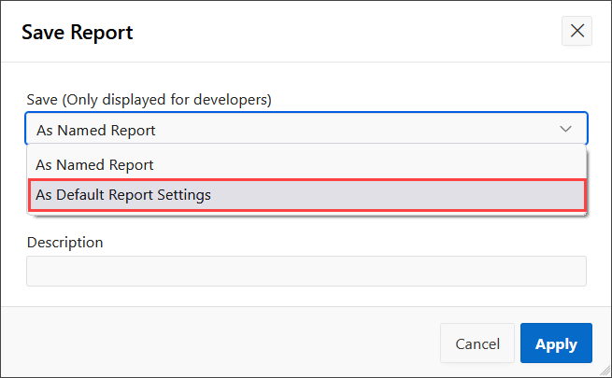

On Save Default Report, select **Alternative**, for Name enter **Best Schools**, and click **Apply**.

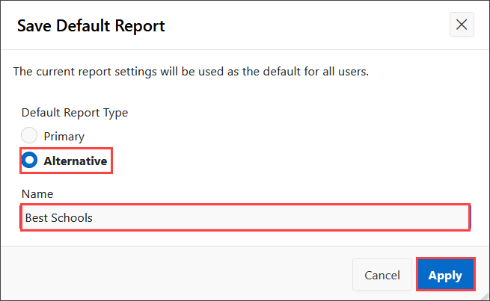

A new select list will be displayed at the top of the report which lists all of the saved reports available to the user.

1. To go back to how the end user will see the report when they first access the report, at the top of the report, select **1. Primary Report**. Click **Actions**, select **Report** and then select **Reset**.

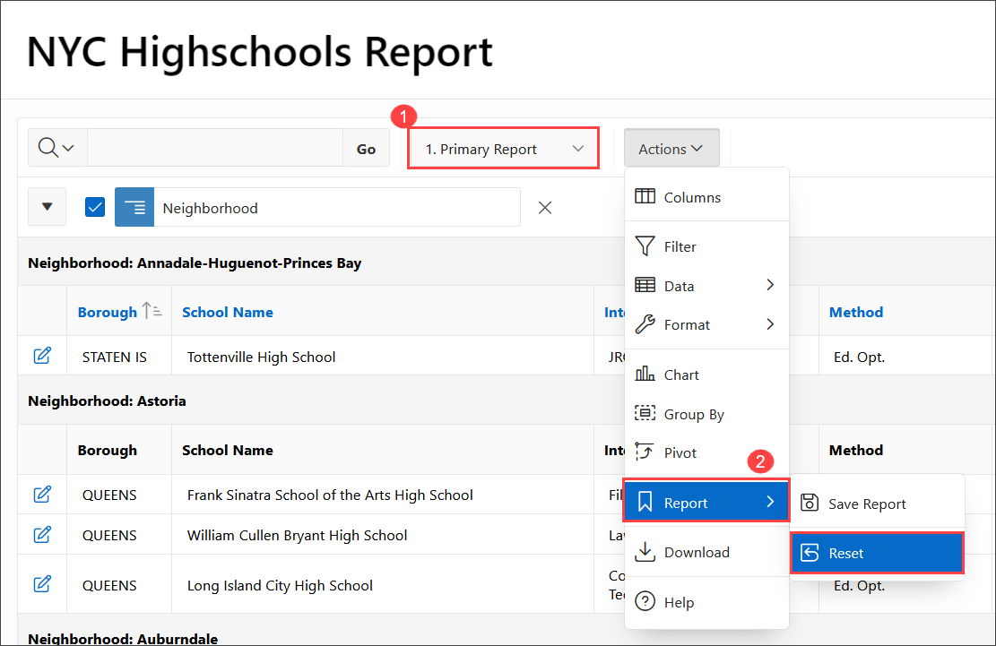

1. Click **Apply** to confirm reset. The changes you have made to the report will be reset and the original report will be displayed.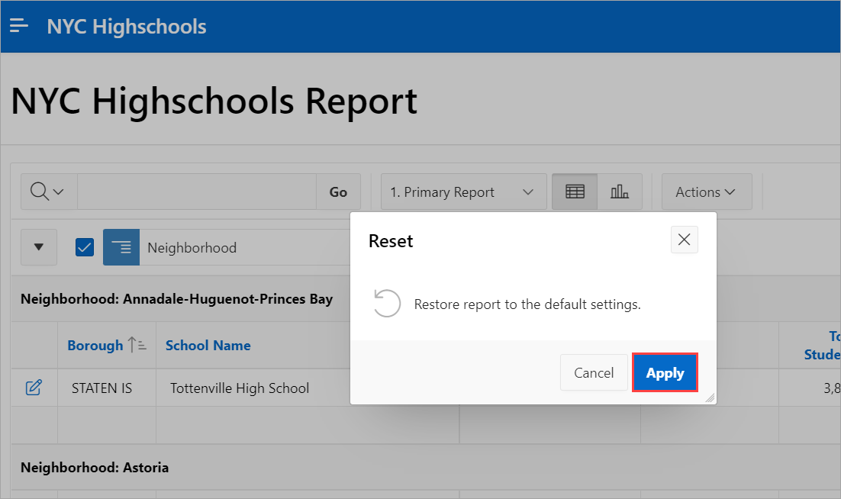

**Task 2: Enhancing the Form**

Form pages allow end users to readily update a single record of information. It is very common for these pages to be modal pages, whereby they display over the top of the original page, and the original page is greyed out and not accessible without first closing the modal page. Advantages of modal pages include that the same page can be called from numerous other pages, they include all of the processing, validations, and so forth within the page definition, and they are user friendly and make for a very straight forward user experience.

By default, the form pages generated by the Create Application Wizard are modal pages. The modal page for maintaining NYC Highschools takes up significant real estate. This could easily be improved by placing the Graduation Rate, Attendance Rate and College Career Rate on the same line. Lastly, the **Borough** allows any values to be entered, so you should restrict data entry by adding a select list of Borough Names.

1. In the Runtime environment, on the **NYC Highschools Report** page, click the **edit icon** for any record.

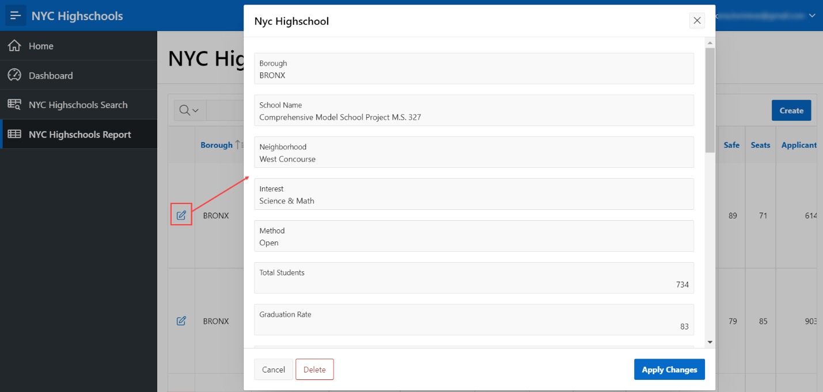

The modal form page for the selected record will be displayed.

1. In the Developer Toolbar, at the bottom of the screen, click **Edit Page 5**.

*Note - If you have difficulties navigating using the Developer Toolbar, manually navigate to the browser tab for the APEX App Builder. If you are on the application home page, navigate to the page by clicking 5 - Nyc Highschool. If already on another page in Page Designer, use the page selector in the toolbar to navigate to page 5.*

1. Items can readily be moved using drag-and-drop within Layout. If required you can also drag *new* components (regions, items, and buttons) from the Gallery, below Layout, into the Layout.

In Page Designer, with Page 5 loaded, within Layout (middle pane), click **P5_ATTENDANCE_RATE** and continue to hold the mouse down. Drag the item up and to the right, until it is directly after **P5_GRADUATION_RATE**, and a dark yellow box is displayed. Release the mouse to drop the item in the new location.

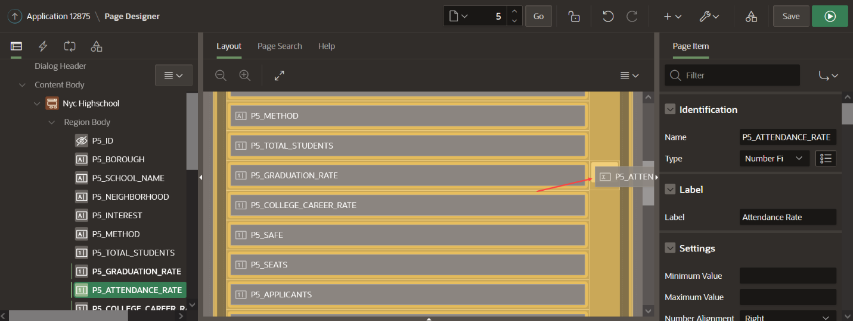

1. As an alternative to using drag-and-drop you can also reposition items using attributes in the Property Editor.

In Page Designer, within Layout (or the Rendering tree in the left pane), select **P5_COLLEGE_CAREER_RATE**. In the Property Editor (right pane), deselect Layout > Start New Row.

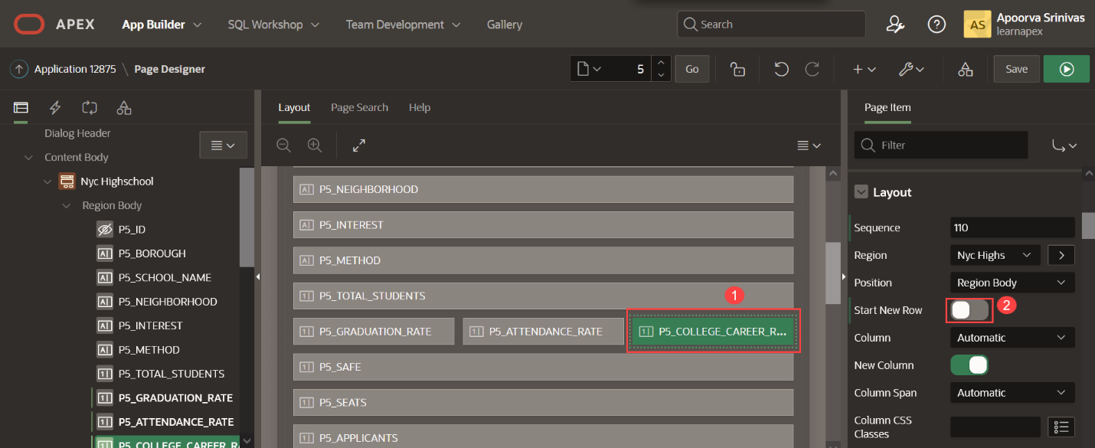

*Note - As soon as you deselect Start New Row, the item will move to be on the same line as the item above, within Layout.*

1. To limit the data entry for an item, one of the simplest techniques is to convert a text item (which allows any data to be entered) into a select list.

In Page Designer, within the Rendering tree (left pane), select **P5_BOROUGH**. In the Property Editor (right pane), enter the following.

| Table 4: Building an App from a Spreadsheet using Oracle APEX | Lab 3: Improve the Report and Form | | |
| --- | --- | --- |
| **Group** | **Attribute** | **Value** |
| Identification | Type | **Select List** |
| List of Values | Type | **SQL Query** |
|  | Display Extra Values | Uncheck |
|  | Null Display Value | Type in **- Select Borough -** |

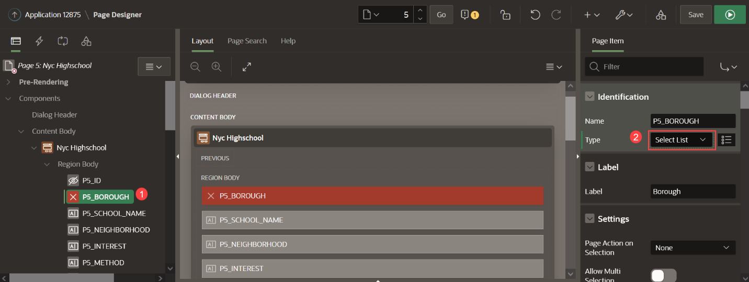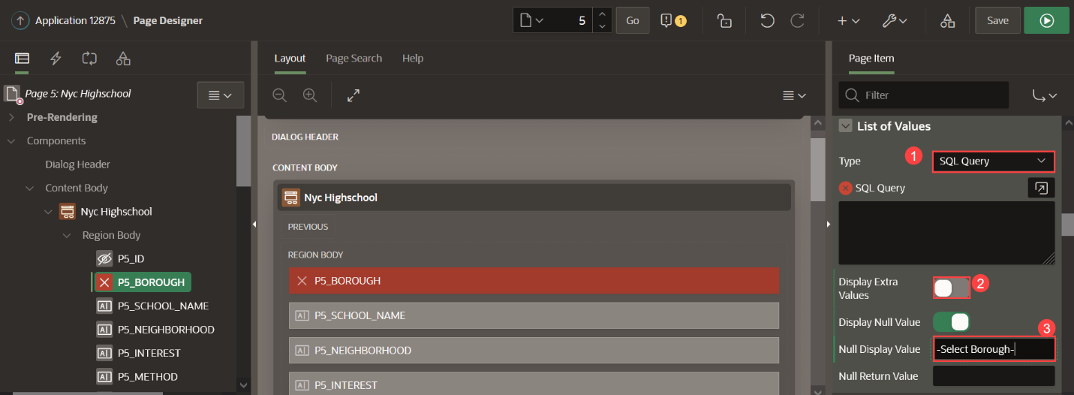

For List of Values > SQL Query enter the following code

Copy**select** **distinct** borough d, borough r

**from** nyc_highschools

**order** **by** 1

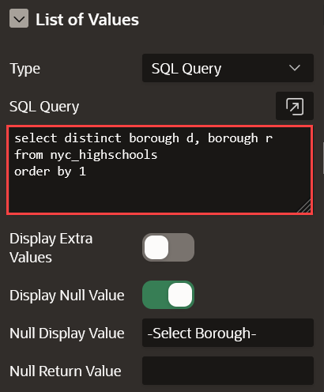

1. It is important to save your changes before testing.

In Page Designer, within the toolbar (at the top), click **Save**.



*Note - If you press Save and Run in the toolbar a message will be displayed, rather than the page being run. This is expected behavior, as modal pages can not be run directly from Page Designer.*

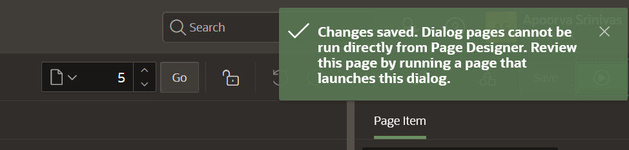

1. Navigate back to the runtime environment and refresh the browser, or click **Cancel** on the modal page to return to the **NYC Highschools Report** page.
2. On the Project Tasks Report page, click the edit icon for any record.

Review the improved layout and click on **Borough** to see the list of available values.

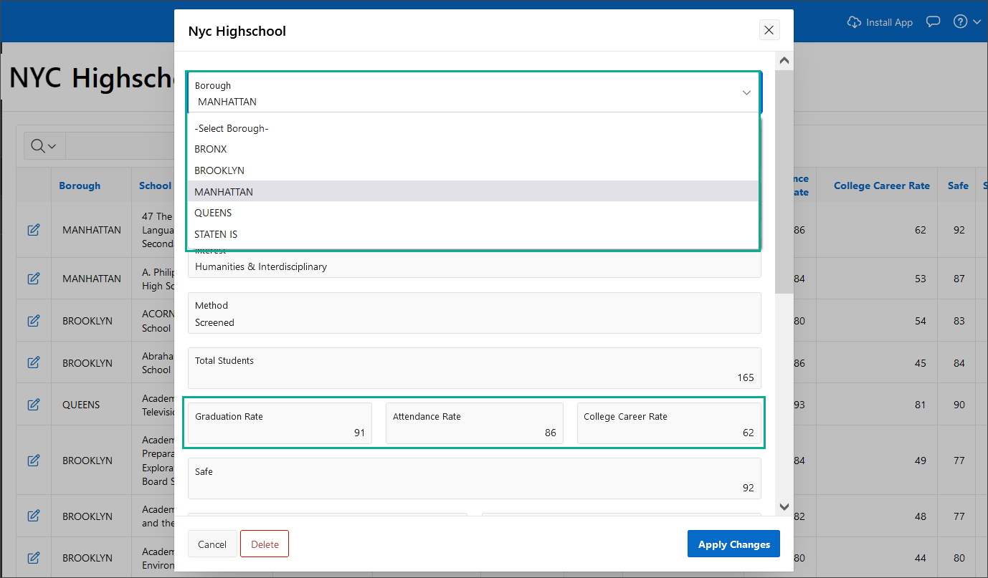

**Task 3: (OPTIONAL) Enhancing the UX of the Form**

In the previous task, you explored a few options to enhance the form. In this task, we further enhance the user experience of the form by splitting the form fields into multiple tabs. Currently, observe that the form contains a number of fields and the user needs to scroll through the form to view all the fields.

1. In the Runtime environment, on the **NYC Highschools Report** page, click the **edit icon** for any record.

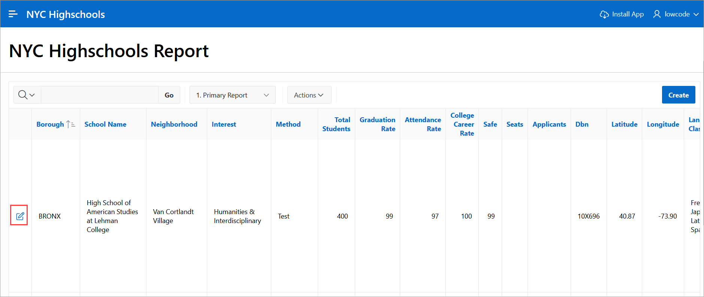

The modal form page for the selected record will be displayed.

1. In the Developer Toolbar, at the bottom of the screen, click **Edit Page 5**.



*Note - If you have difficulties navigating using the Developer Toolbar, manually navigate to the browser tab for the APEX App Builder. If you are on the application home page, navigate to the page by clicking 5 - Nyc Highschool. If already on another page in Page Designer, use the page selector in the toolbar to navigate to page 5.*

1. Click **Nyc Highschool** in the rendering tree. In the Property Editor, navigate to **Appearance** and for Template select **Tabs Container**.

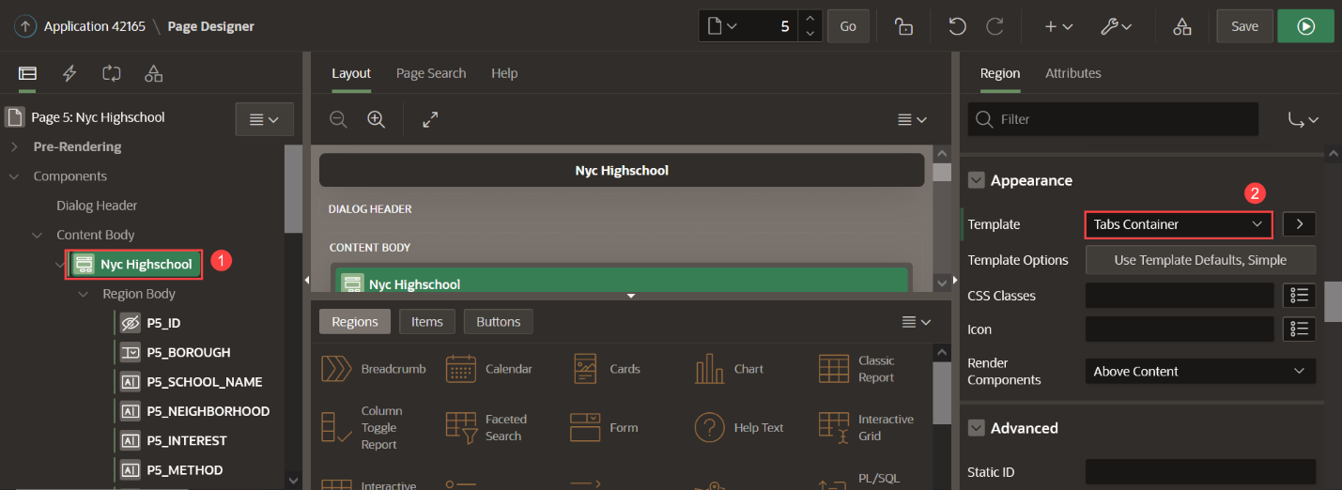

1. To create a tab, right-click on **Nyc Highschool** and select **Create Sub Region**. Create 4 Sub Regions with the following values for **Title**:
   * General Information
   * Metrics
   * Location
   * Other Course Details

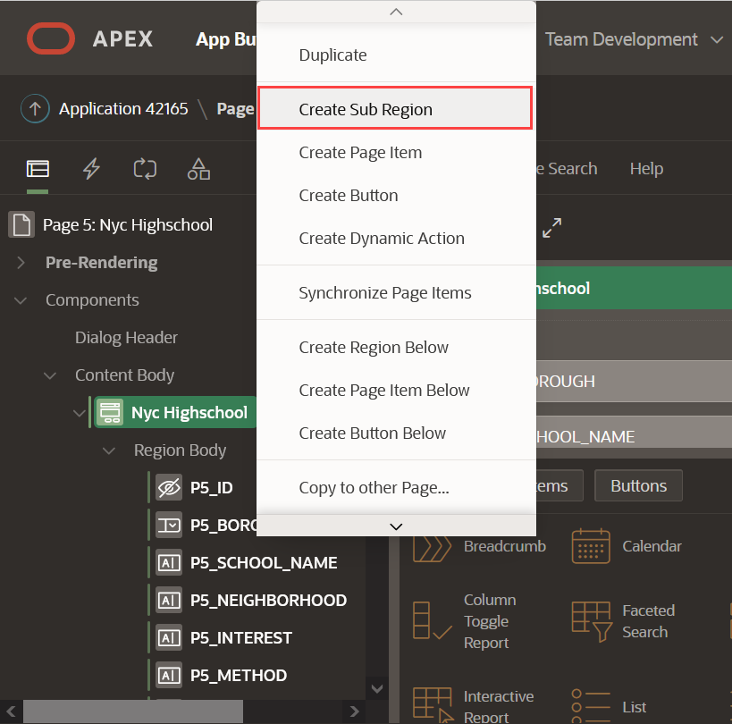

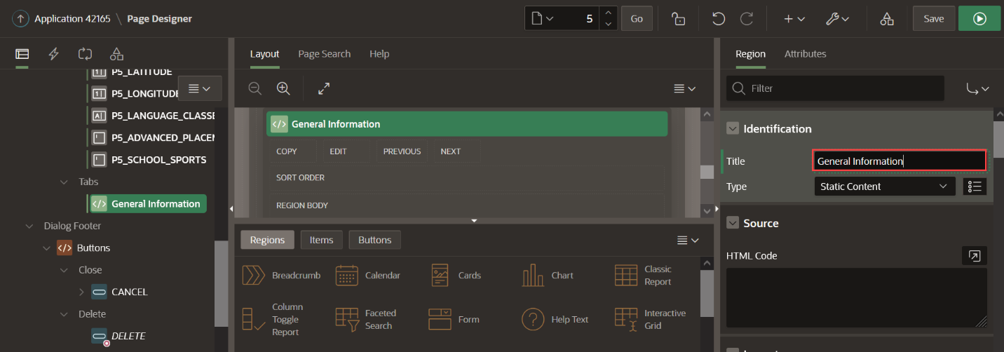

1. In the Property Editor for each Sub Region, perform the following step:
   * Navigate to **Appearance**
   * Select **Template Options**
   * For **Header**, select **Hidden but accessible**

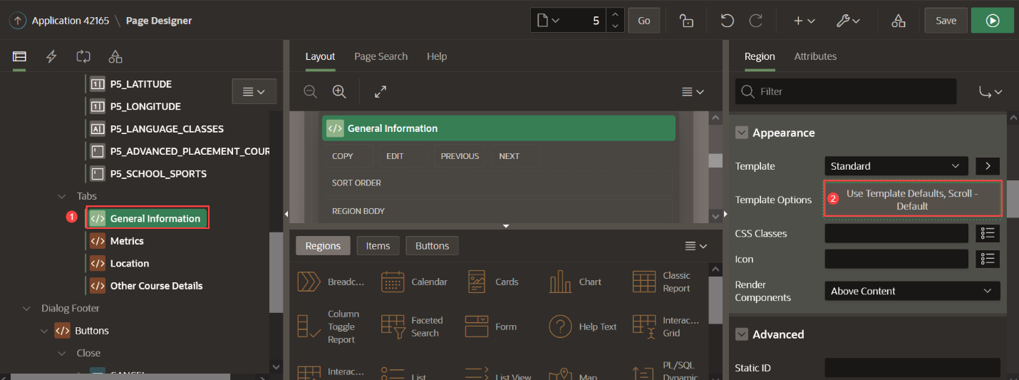

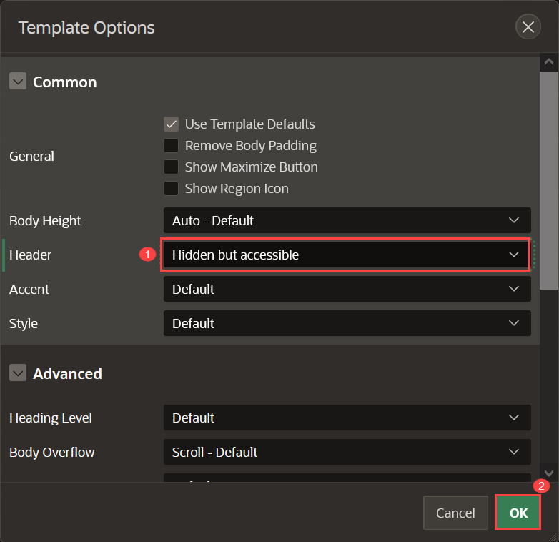

1. The Sub Regions created represents the different tabs. Drag and drop the form fields into their respective Sub Region as mentioned in the table.

| Table 5: Building an App from a Spreadsheet using Oracle APEX | Lab 3: Improve the Report and Form | |
| --- | --- |
| **Sub Region Title** | **Form Fields** |
| **General Information** | P5_BOROUGH P5_SCHOOL_NAME P5_NEIGHBORHOOD P5_INTEREST P5_METHOD |
| **Metrics** | P5_TOTAL_STUDENTS P5_GRADUATION_RATE P5_ATTENDANCE_RATE P5_COLLEGE_CAREER_RATE P5_SEATS P5_APPLICANTS P5_SAFE |
| **Location** | P5_LATITUDE P5_LONGITUDE |
| **Other Course Details** | P5_DBN P5_LANGUAGE_CLASSES P5_ADVANCED_PLACEMENT_COURSES P5_SCHOOL_SPORTS |

1. 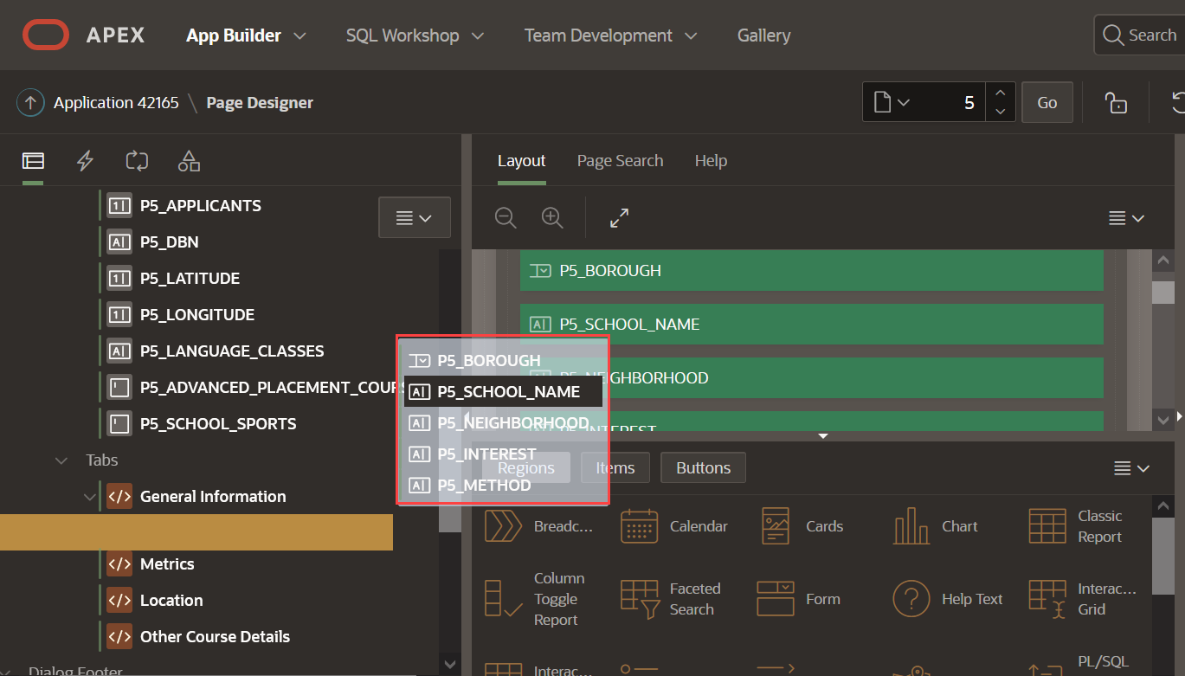
2. Click **Save** to save your changes. Go to the runtime application and refresh the application. On the **NYC Highschools Report** page, click the **edit icon** for any record. Click on various tabs to view the form fields.

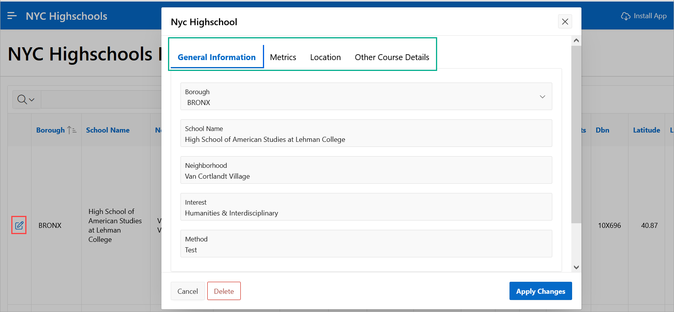

**Summary**

You now know how *end-users* can define custom reports using Interactive Reports, and you can easily improve form pages.

# Using Maps and Progressive Web App

**Introduction**

In this lab, you learn to add a map region to the search page in order to visually enhance the page. The search page includes facets on the left which can readily be used to limit the data shown in the map on the right. Once the final application is built, you learn to download and use the application as a Progressive Web App (PWA).

Estimated Time: 10 minutes

Collapse All Tasks

**Task 1: Creating a Copy of an Existing Page**

In order to implement the map, we will copy the existing **NYC Highschools Search** page and modify the new page to include the Map region.

1. From the runtime application, go to the search page by clicking **NYC Highschools Search**. Assuming that you ran this app from the APEX App Builder, a Developer Toolbar is displayed at the bottom of the screen. *Note - End users who log directly into the app will not see this toolbar.*

In the Developer Toolbar click **Page 3**.

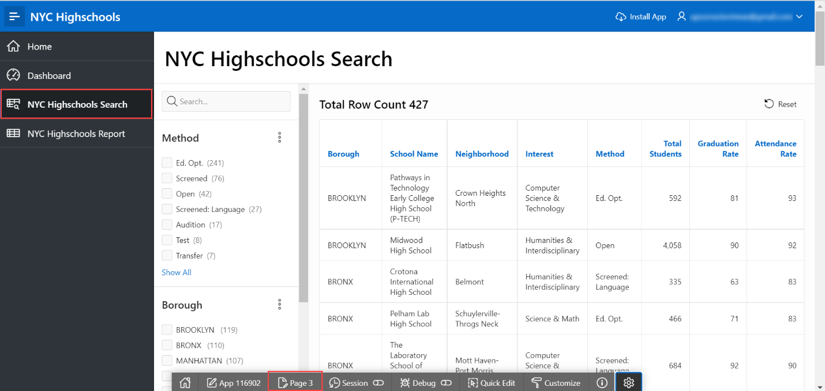

Alternatively, you can also navigate back to the APEX App Builder tab in your browser manually by selecting the appropriate browser tab or window. Once in the App Builder click **3 - NYC Highschools Search**.



1. To create a page similar to the existing page, click the + icon next to the redo button at the top right corner. Select **Page as Copy**.

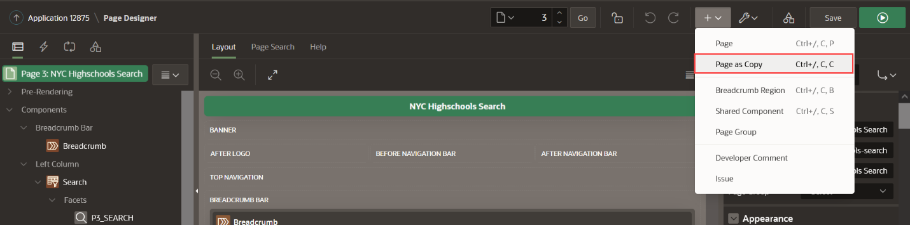

1. A Copy Page dialog appears. For Create a page as a Copy of, select **Page in this application** and click **Next**.

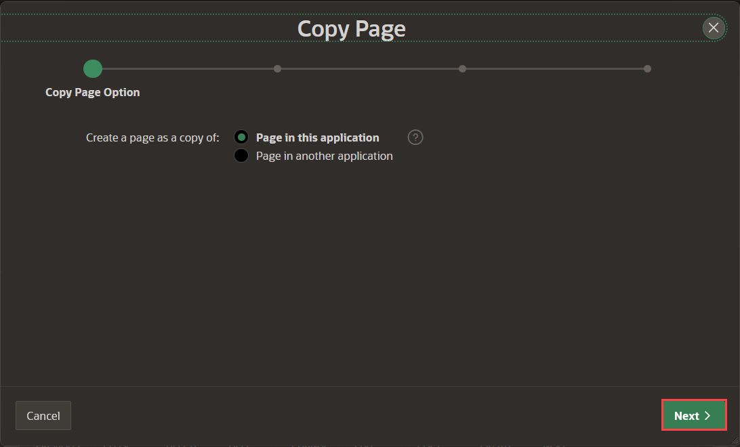

1. For Page to Copy, enter the following:

* For New Page Name, enter **NYC Highschools Map**
* For Breadcrumb, select the Breadcrumb option
* For Entry Name - accept the default value or enter **NYC Highschools Map** Accept the default values for other fields and click **Next**.

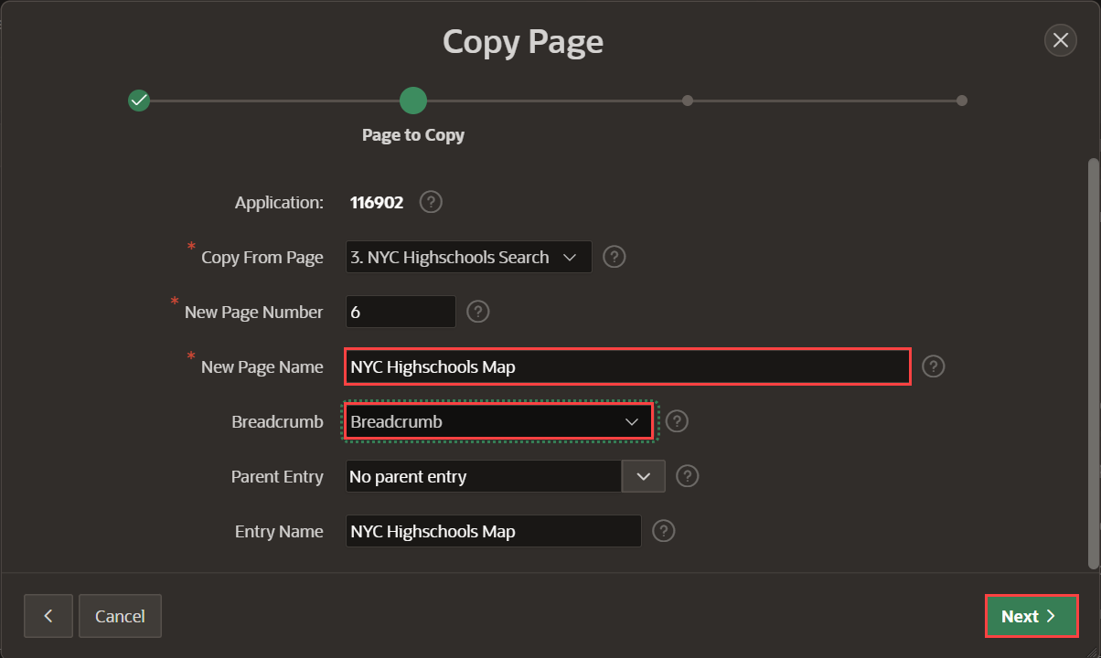

1. Under Navigation Menu, select **Create a new navigation menu entry** and click **Next**. This creates a new entry in the left side navigation menu of your application.

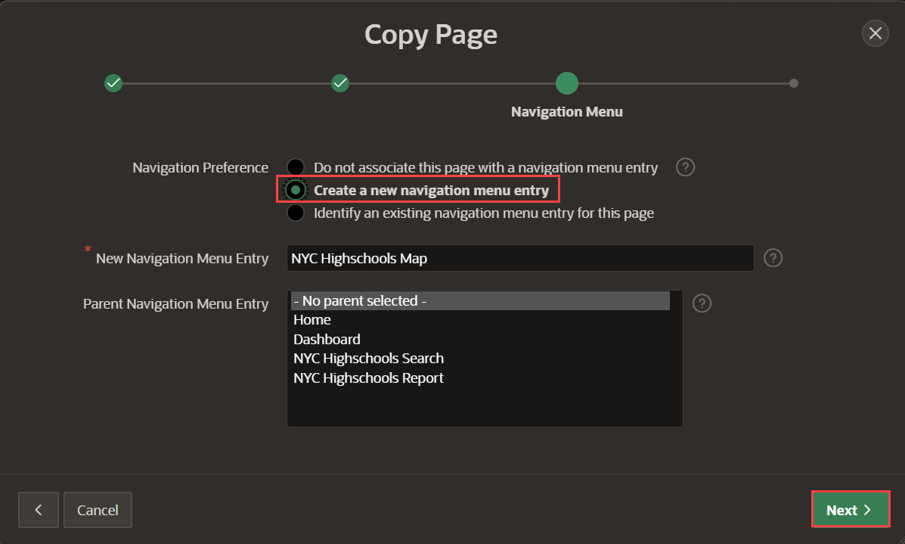

1. Under New Names, you can enter new names for the items and buttons. Accept the default names and click **Copy**.

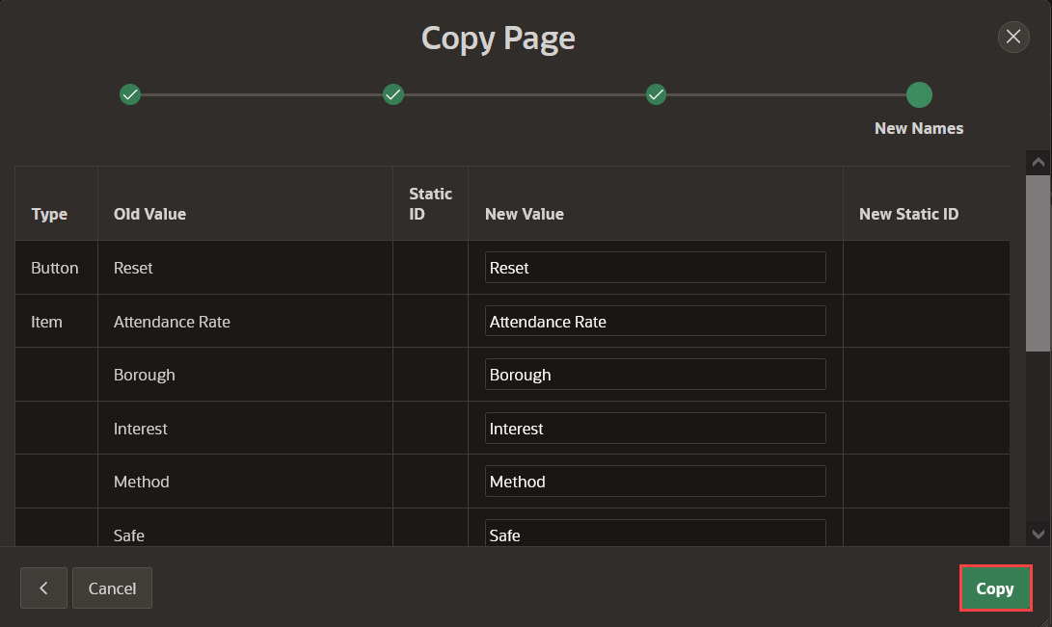

A new page called **NYC Highschools Map** is created as Page 6.

**Task 2: Adding a Map Region**

1. The newly created Page 6, **NYC Highschools Map** opens in the Page Designer. In the Rendering pane, navigate to Body and select the **Nyc Highschools** region. In the Property Editor, change the type to **Map**.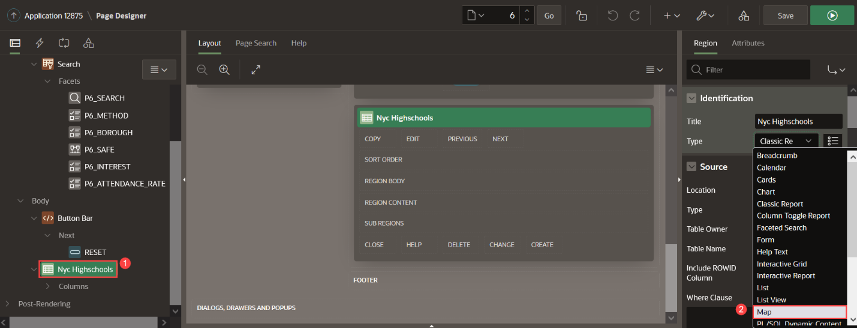
2. To customize a map region, you need to add layers. Under Layers, click on **New**. In the property editor, perform the following:
   * For Name, enter **Schools**
   * For Source > Location, select **Region Source**. This indicates that the layer fetches the data from it's parent region (Nyc Highschools) whose source is the local database table *NYC_HIGHSCHOOLS*.

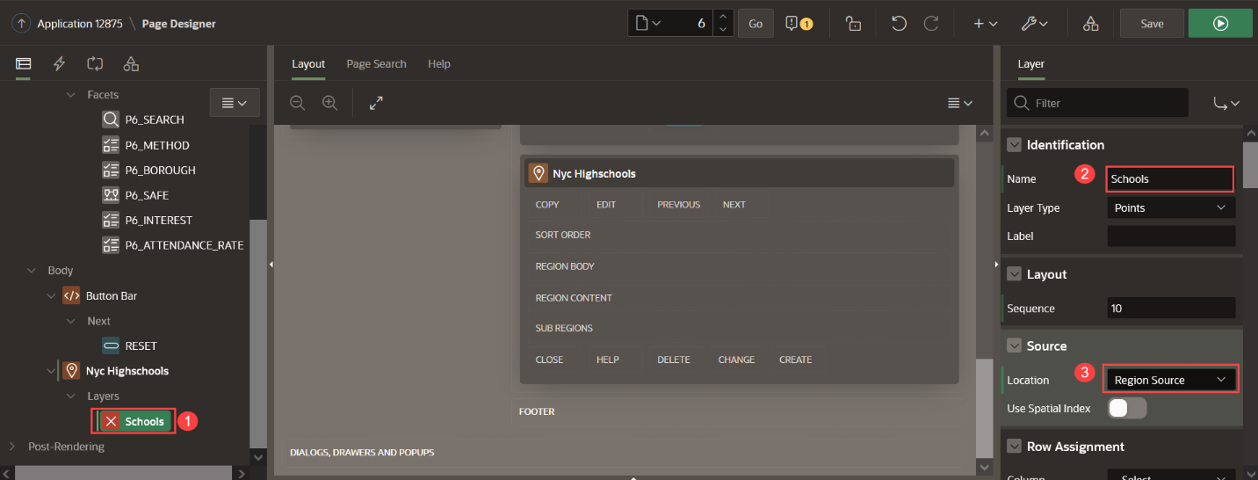

1. In order to display the points on the map, you need to provide the coordinates. In the Property Editor, go to the **Column Mapping** group. Enter the following values:

| Table 1: Building an App from a Spreadsheet using Oracle APEX | Lab 4: Add a Map Region and Install PWA | |
| --- | --- |
| **Property** | **Value** |
| Geometry Column Data Type | Longitude/Latitude |
| Longitude Column | Longitude |
| Latitude Column | Latitude |

1. 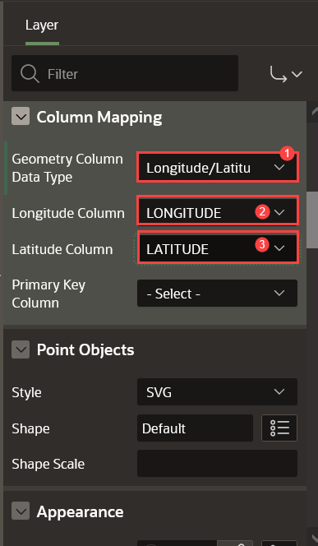
2. Click on **Save**. Later, click on **Application \** at the top to navigate to the application home page.



1. Let us set an icon for the newly created **NYC Highschools Map**. Click on **Shared Components**.

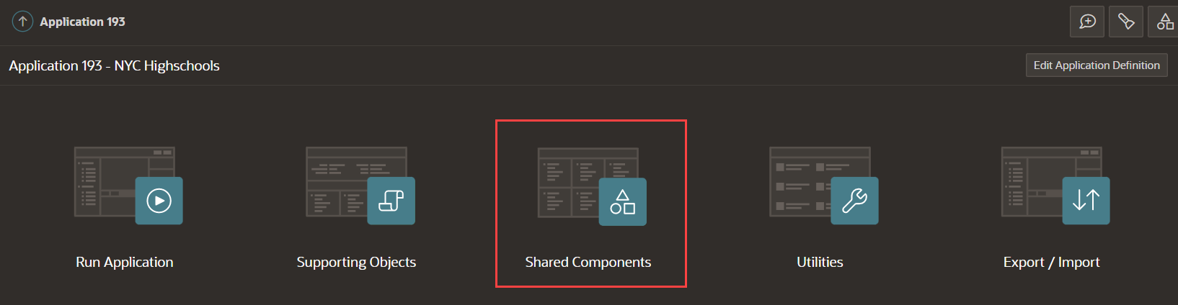

1. Under Navigation, select **Navigation Menu**. Under Lists, select **Navigation Menu**.

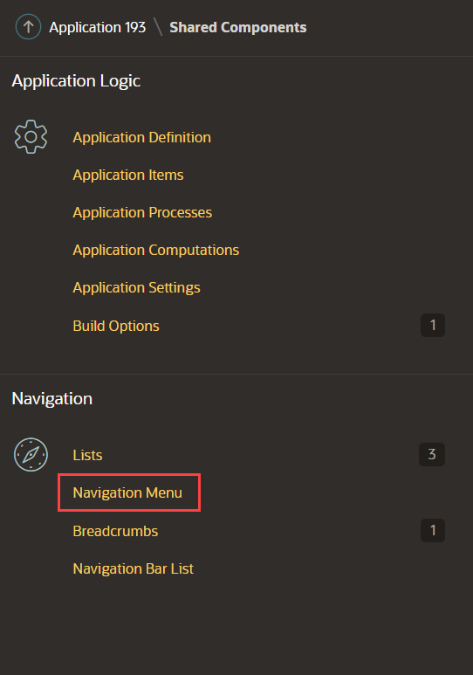

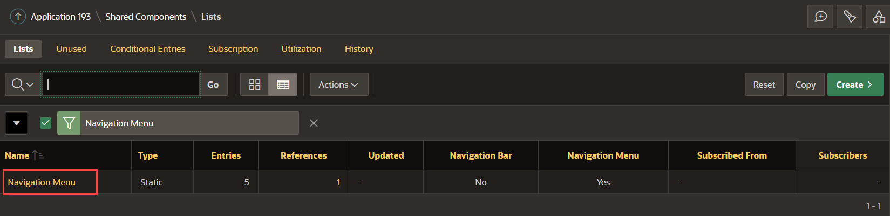

1. Click the edit icon next to **NYC Highschools Map** list entry.

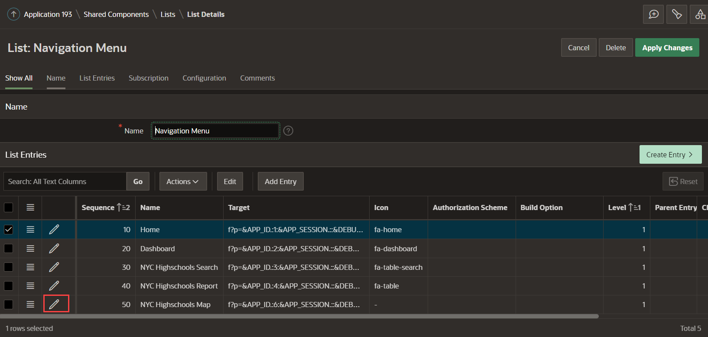

1. In the edit page, for Image/Class enter **fa-map-marker** and click **Apply Changes**.

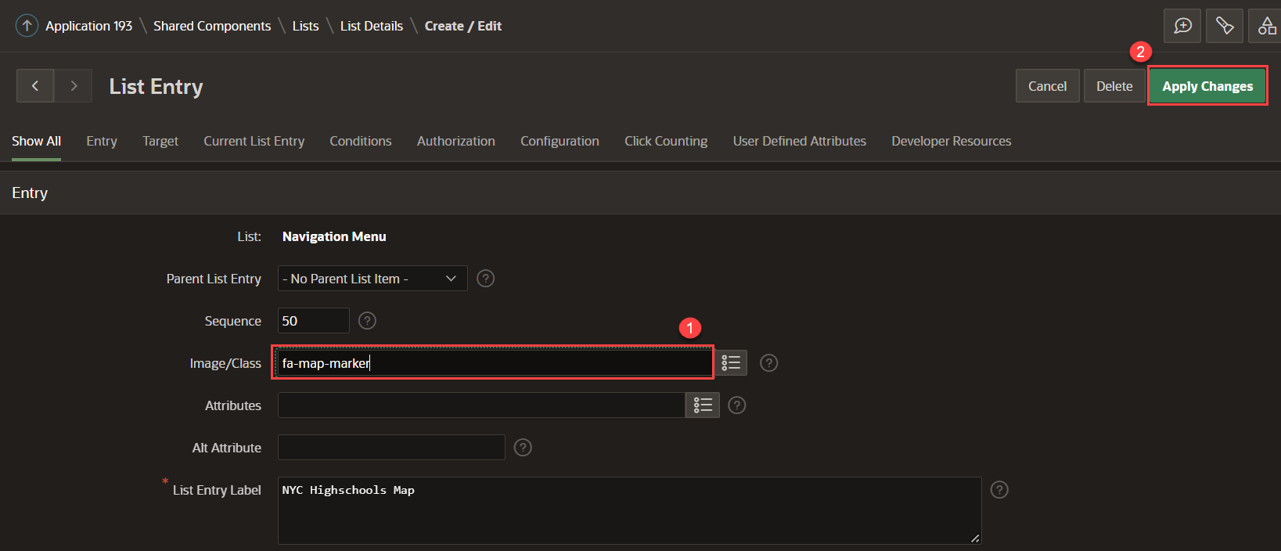

1. Click **Run Page**. The **NYC Highschools Map** is displayed with a faceted search on the left and a map region on the right. Filter the values using faceted search and observe how the map changes accordingly.

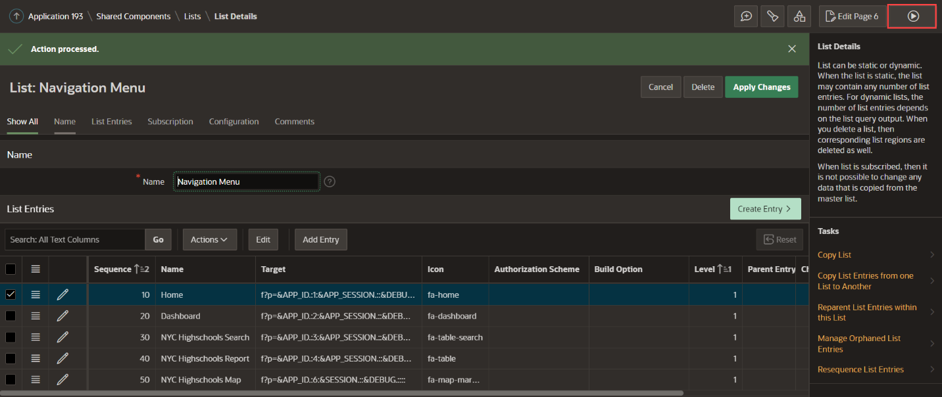

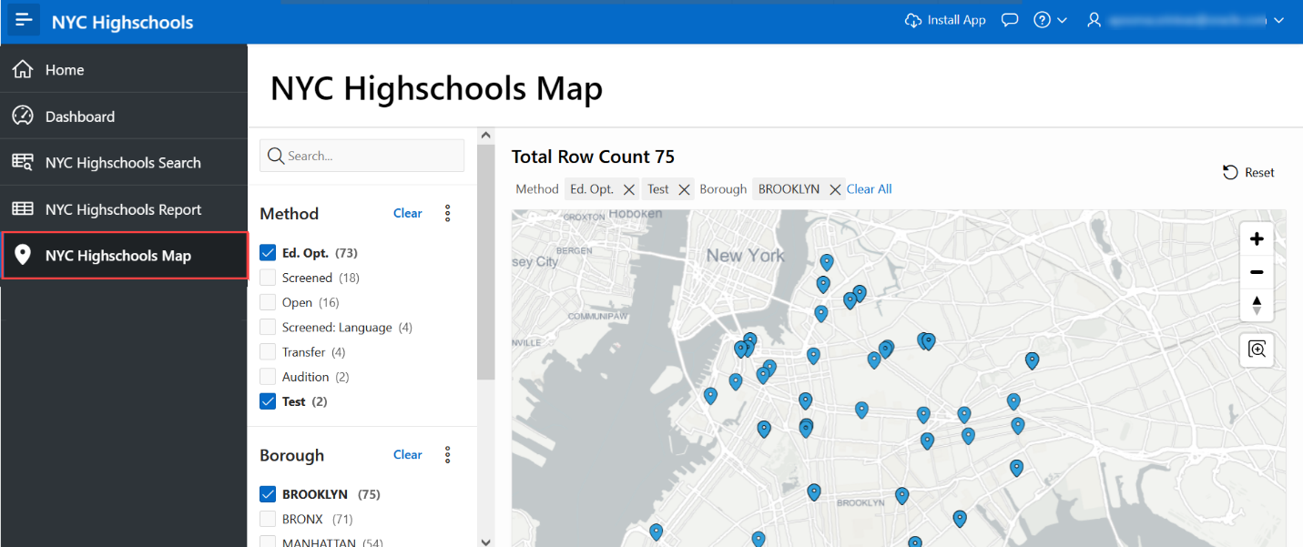

**Task 3: Enhancing the Map Region**

APEX allows customization of the map in a declarative way. In this step, you will enhance the map by adding tooltip and custom pin colors on the map.

1. From the **NYC Highschools Map** page in the application, click **Page 6** in the developer toolbar to edit the page.
2. In the Rendering tree, navigate to **Nyc Highschools** under Body and select the **Schools** layer.  
   In the Property Editor, do the following:
   * Under Tooltip, toggle the button to switch on **Advanced Formatting**.
   * In the **HTML Expression** text area, enter the following HTML snippet:
   * Copy<**strong**>&SCHOOL_NAME.</**strong**><**br**>

Borough: &BOROUGH.<br

1. 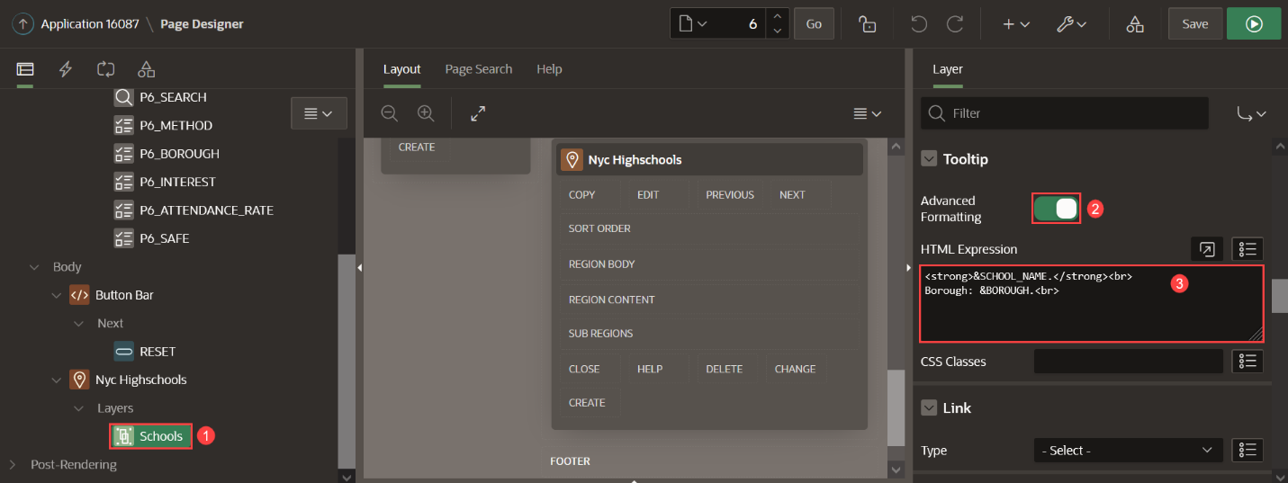
2. Click **Save and Run Page**. The NYC Highschools Map is displayed. Hover over a pin in the map to display the custom tooltip. The tooltip displays the Highschool name and the Borough name.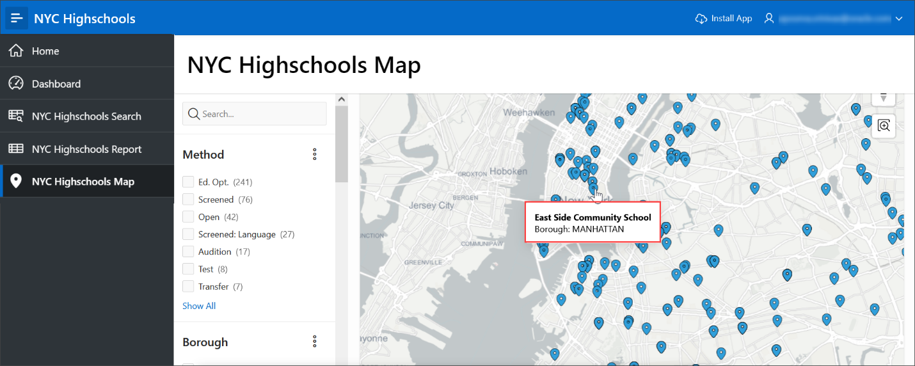
3. Now, you will customize the map by adding a condition such that the value of the *GRADUATION_RATE* will determine the pin color. To do so, click **Page 6** in the developer toolbar to edit the page.
4. In the Rendering tree, navigate to **Nyc Highschools** under Body. In the Property Editor, under Source, select **SQL Query** for Type. Click on the Code Editor button next to SQL Query.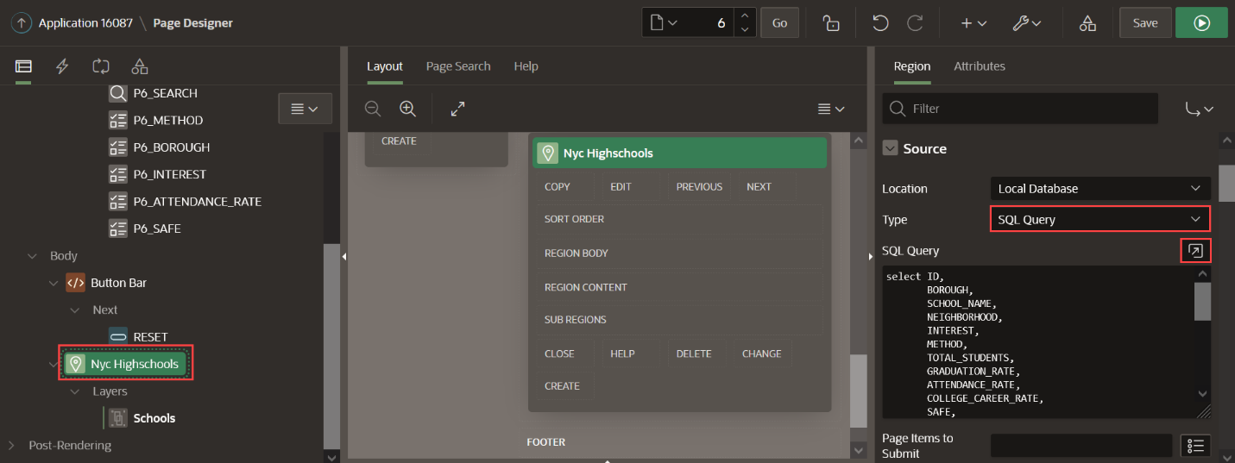
5. In the Code Editor, modify the SQL query to add a CASE statement to determine the color based on the value of *GRADUATION_RATE*. Replace the query with the following query:
6. Copy**select** ID,
7. BOROUGH,
8. SCHOOL_NAME,
9. NEIGHBORHOOD,
10. INTEREST,
11. **METHOD**,
12. TOTAL_STUDENTS,
13. GRADUATION_RATE,
14. ATTENDANCE_RATE,
15. COLLEGE_CAREER_RATE,
16. SAFE,
17. SEATS,
18. APPLICANTS,
19. DBN,
20. LATITUDE,
21. LONGITUDE,
22. LANGUAGE_CLASSES,
23. ADVANCED_PLACEMENT_COURSES,
24. SCHOOL_SPORTS,
25. **CASE** **WHEN** GRADUATION_RATE **BETWEEN** 0 **and** 50 **then** 'red'
26. **WHEN** GRADUATION_RATE **BETWEEN** 50 **and** 75 **then** 'yellow'
27. **WHEN** GRADUATION_RATE **BETWEEN** 75 **and** 100 **then** 'green' **END** **as** PIN_COLOR

**from** NYC_HIGHSCHOOLS

Click **OK**.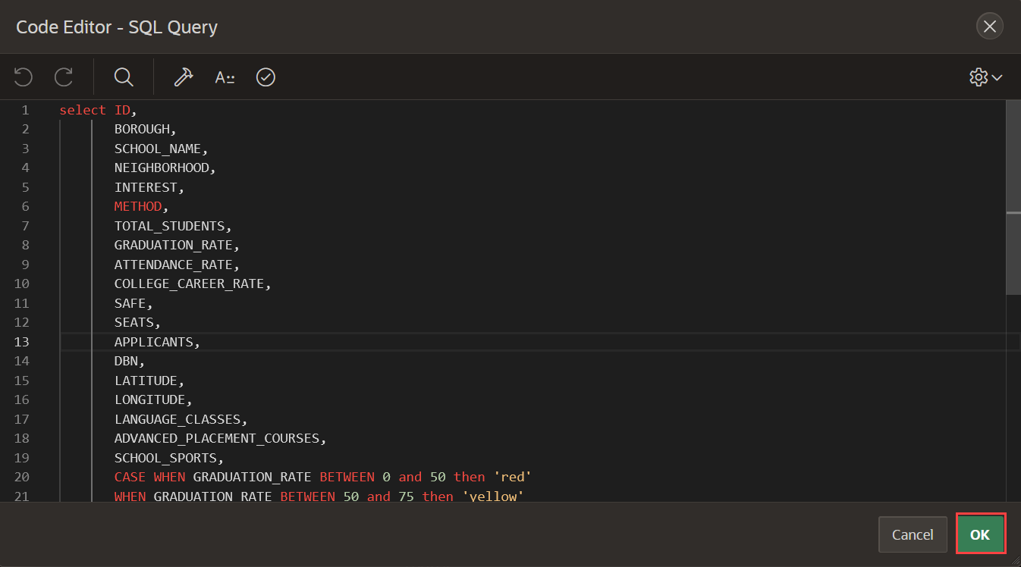

1. Select **Schools** layer in the Rendering pane. In the Property Editor, do the following:
   * For **Name**, enter **Schools - Red**
   * Under **Row Assignment**,
     + For **Column**, select **PIN_COLOR**
     + For **Value for this Layer**, enter **red**
   * Under **Appearance**, for Fill Color enter **&PIN_COLOR.**

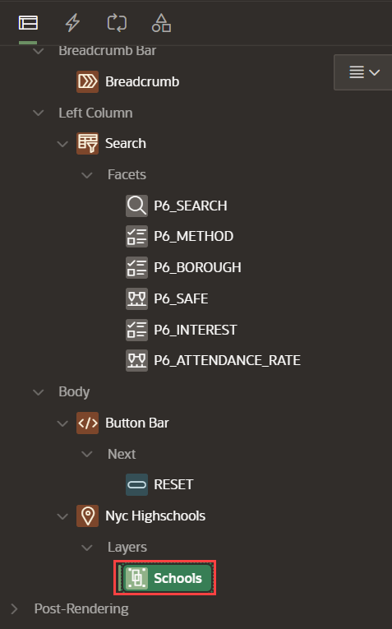

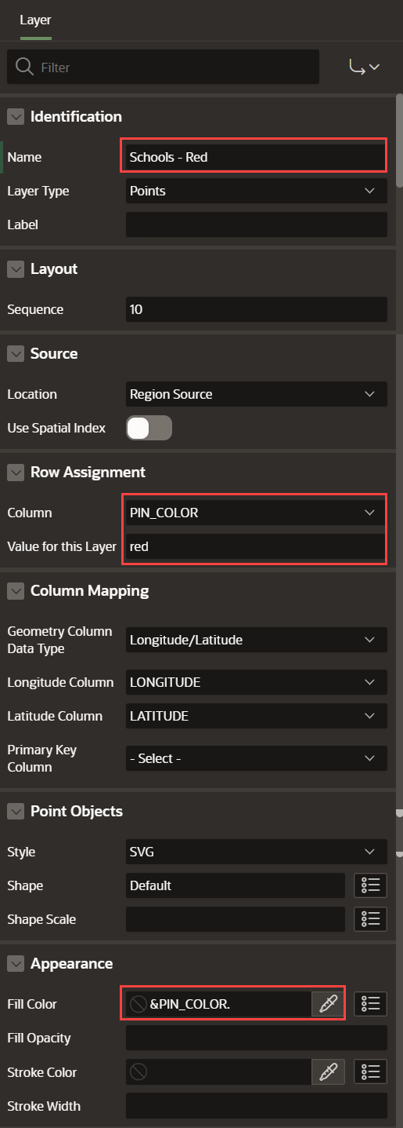

1. In the Rendering Pane, right-click on **Schools - Red** and select **Duplicate**. In the Property Editor, do the following:
   * For **Name**, enter **Schools - Green**
   * Under **Row Assignment**, for **Value for this Layer**, enter **green**

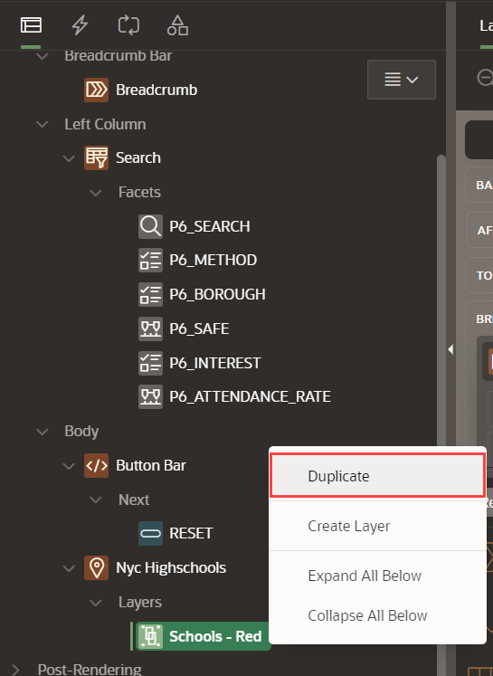

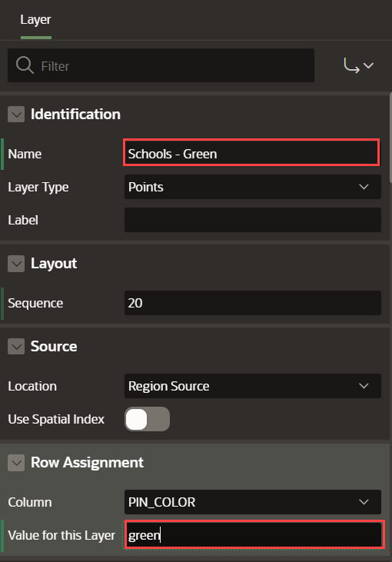

1. In the Rendering Pane, right-click on **Schools - Green** and select **Duplicate**. In the Property Editor, do the following:
   * For **Name**, enter **Schools - Yellow**
   * Under **Row Assignment**, for **Value for this Layer**, enter **yellow**

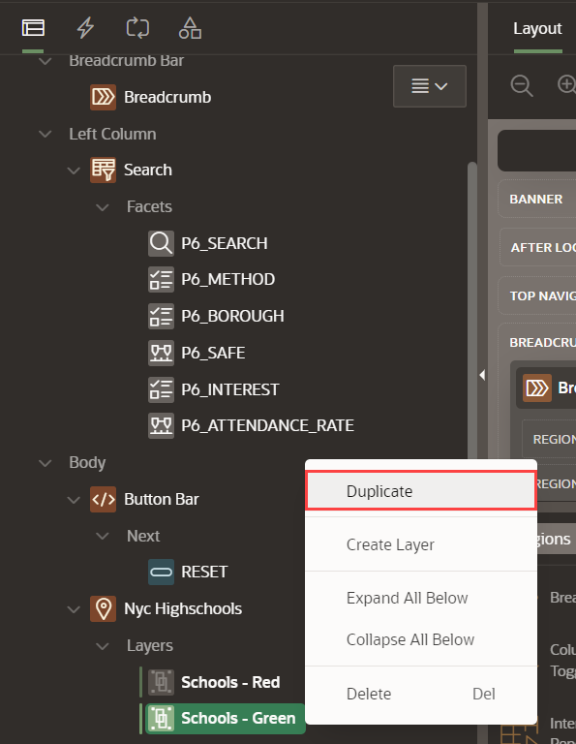

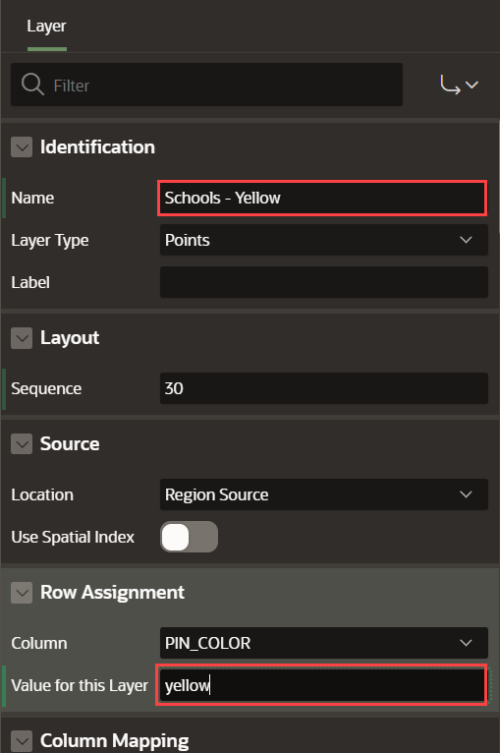

1. Click **Save and Run** page. The **NYC Highschools Map** displays different colors for the pins.
   * The schools with a Graduation rate between 0-50 are displayed in **red**
   * The schools with a Graduation rate between 50-75 are displayed in **yellow**
   * The schools with a Graduation rate between 75-100 are displayed in **green**

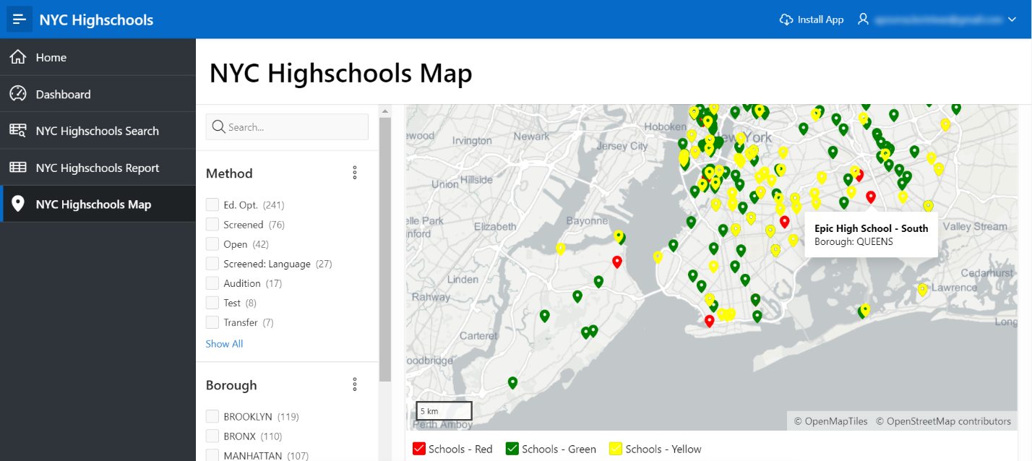

**Task 4: Installing a Progressive Web App (PWA)**

**Progressive Web Applications (PWA)** are designed to be fast, responsive, installable to a home screen, reliable (online or offline), and engaging (providing support for push notifications).

Recall that you created a Progressive Web App by running the Create Application Wizard and enabling the Install Progressive Web App feature in Lab 1 of this workshop. In this step, you will learn to install and use a PWA.

*Note*:

* To enable Progressive Web App, an Oracle APEX application must be served over a secured HTTPS environment, or localhost. If using an unsecured environment, PWA features will not be rendered.
* PWA is available in Google Chrome, Microsoft Edge and Safari browsers. Firefox does not support PWA.

1. To install a PWA, go to your application and click **Install App** on the navigation bar.

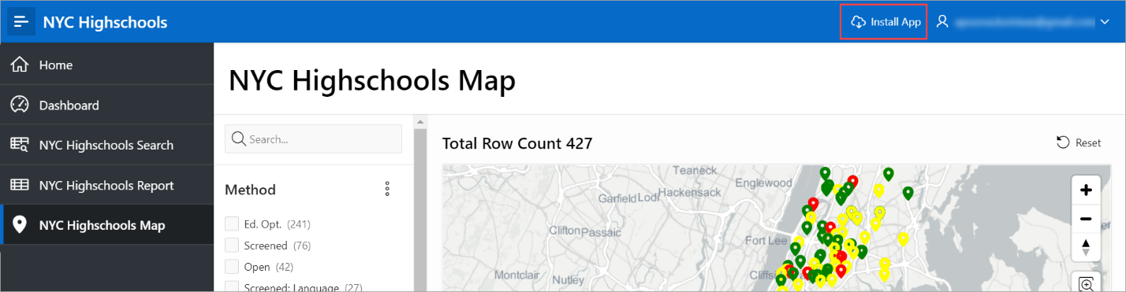

1. A popup dialog appears in your browser asking you whether you want to install the app. Click **Install**.

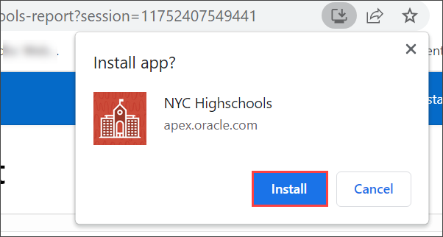

1. After a few seconds, the application icon is created on your desktop/home screen. Double-click the application icon.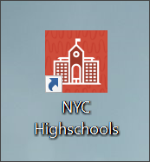
2. The application is now open as a PWA without the need for a browser. This provides a customizable offline page when users are offline and cannot request the network. It optimizes page loading speed on the mobile device. It also improves the page load rendering time.

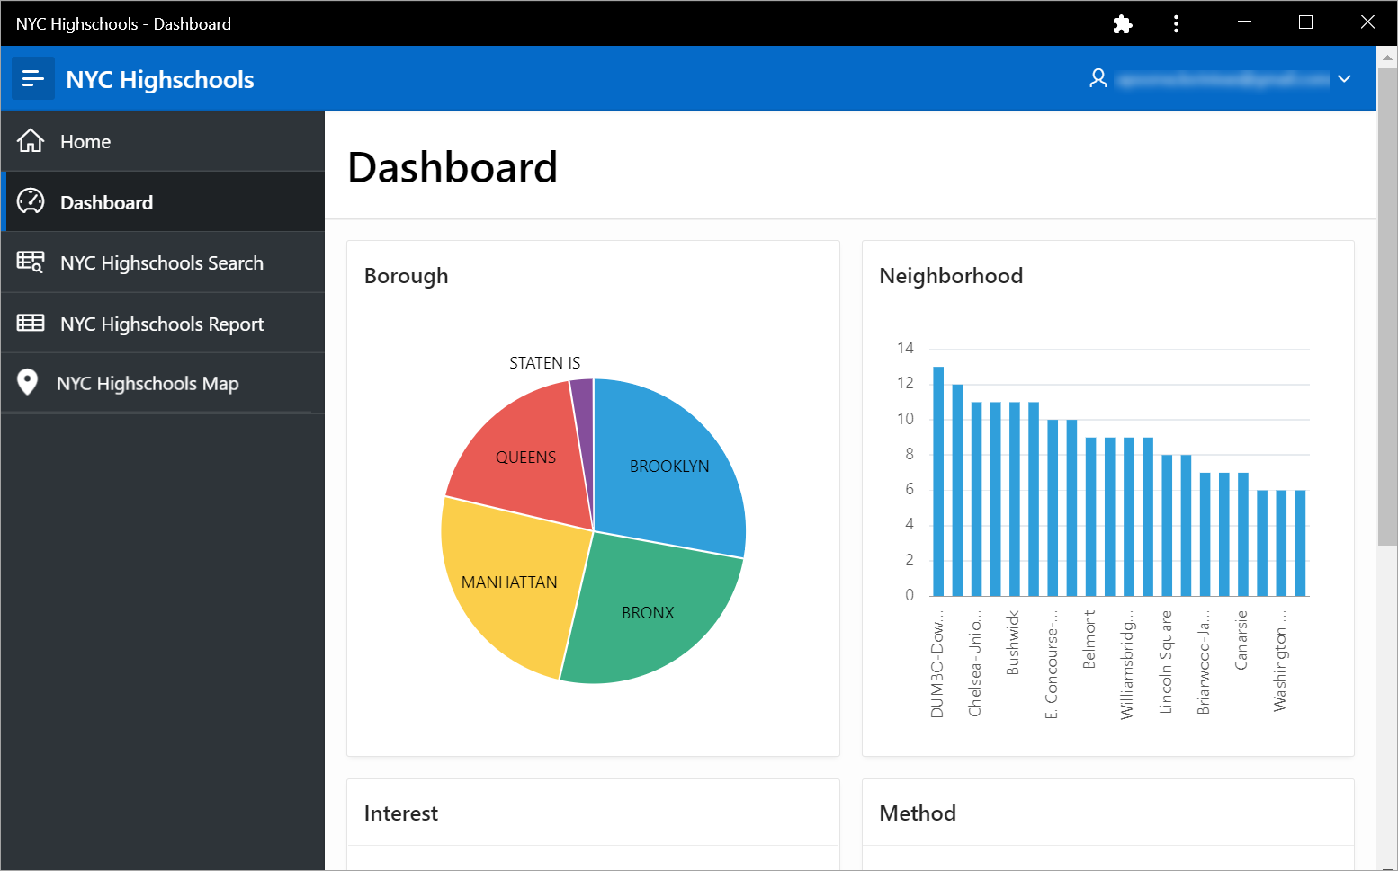

**Summary**

You now know how to embed a maps in your application and to install a Progressive Web App (PWA).